

Project Title: Inventory and Warehouse Management System

Course: Unstructured Database Lab
Course Code: CSE12203
Submitted to: Ms. Anusuya Bera
Submitted by:
- Ankita Biswas (UG/02/BTCSECSF/2023/019)
- Ankita Das (UG/BTCSECSF/2023/017)
- Digant Mishra (UG/02/BTCSECSF/2023/016)
- Saubantik Das (UG/02/BTCSECSF/2023/015)
Session: 2025-2026

Introduction
This project is made to manage warehouse stock and product movement.
We used a Swiggy Instamart type use case where products are stored in a dark store.
The system helps in stock tracking, supplier handling, and transaction recording.
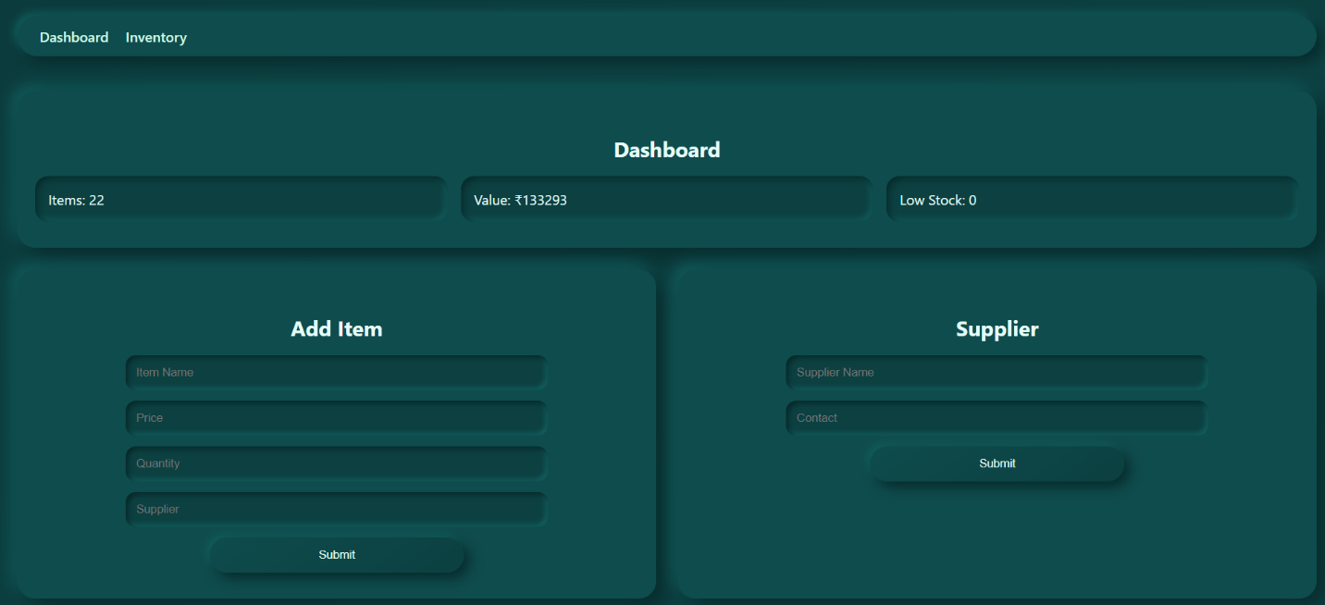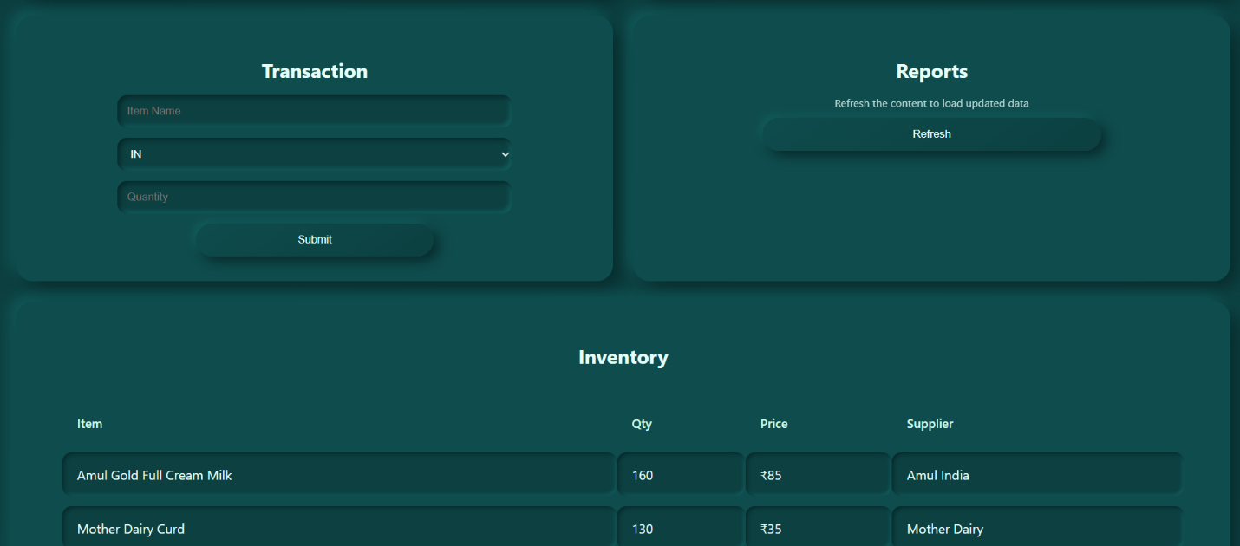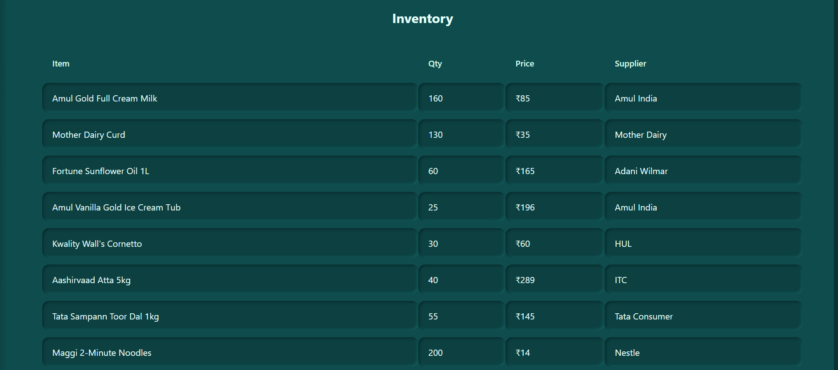
Objective
- To manage item stock and supplier details
- To track IN and OUT movement of products
- To generate stock reports and low stock alerts
Technologies Used
- Frontend: HTML, CSS, JavaScript
- Backend: Node.js, Express.js
- Database: MongoDB, Mongo Shell, Compass
Database Collections
- Items collection stores product details
- Suppliers collection stores supplier records
- Transactions collection stores stock movement logs
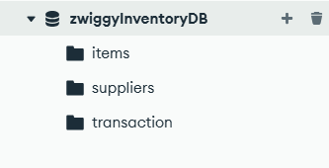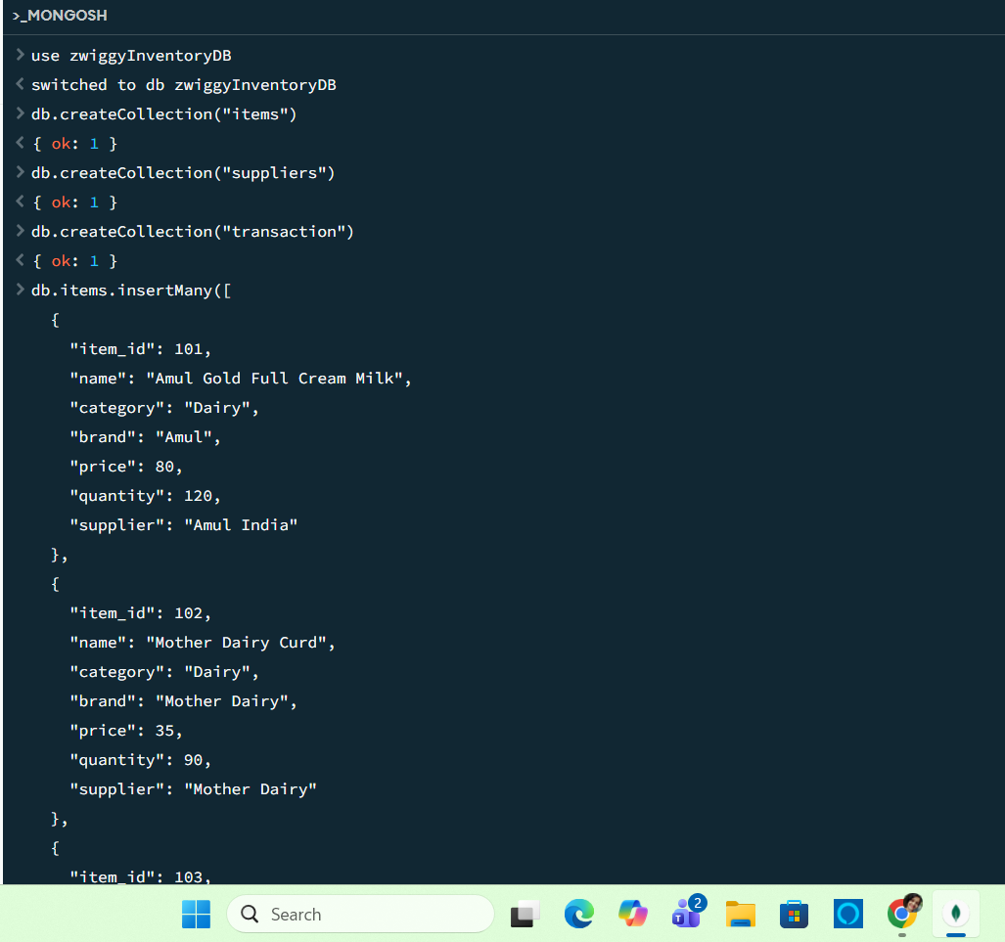
CRUD Operations
- Insert product and supplier data
- Read records using find queries
- Update and delete stock records when needed
For ‘items’ collection
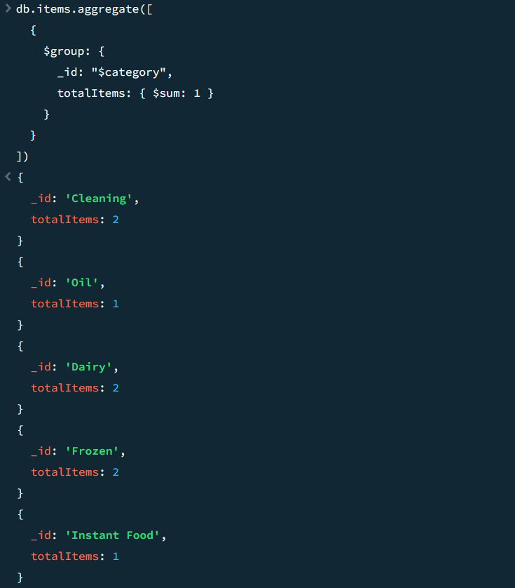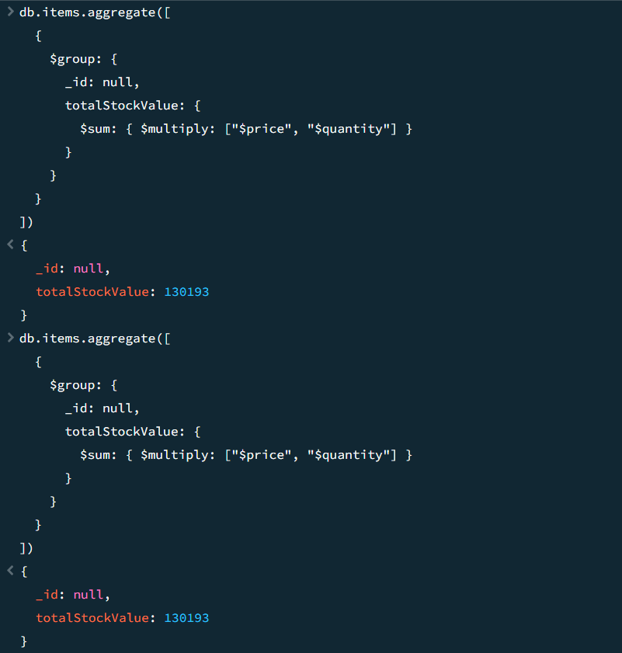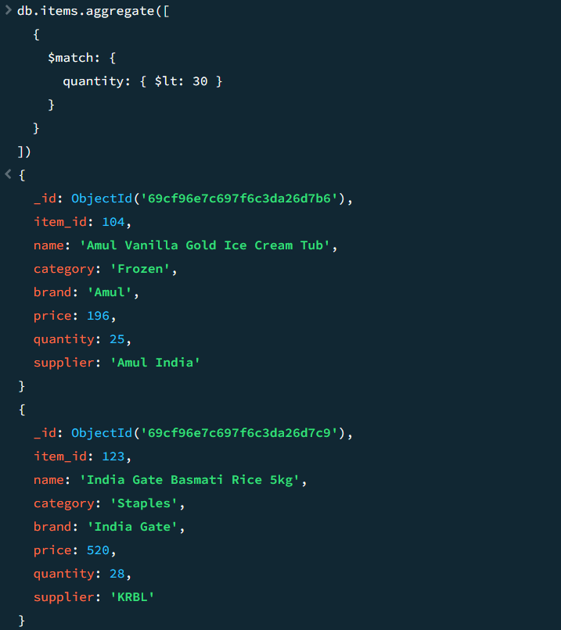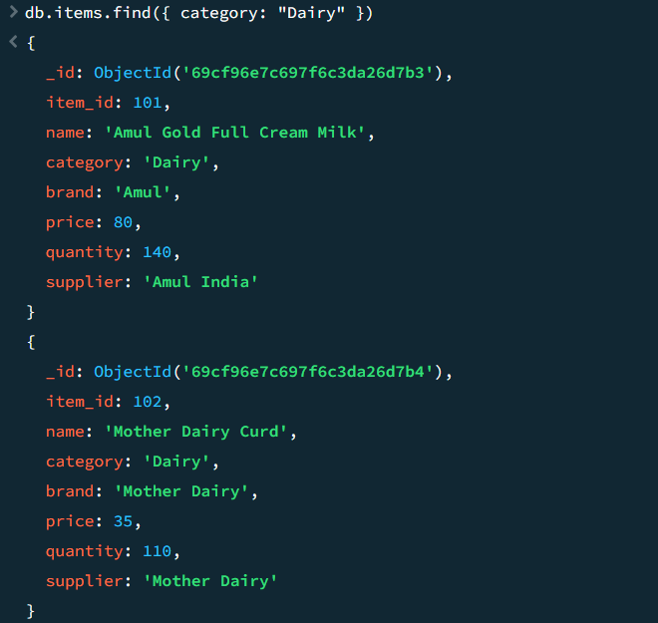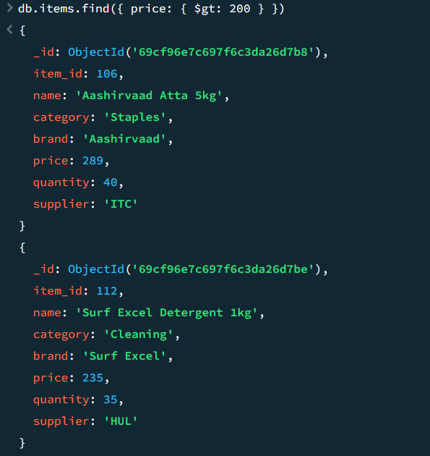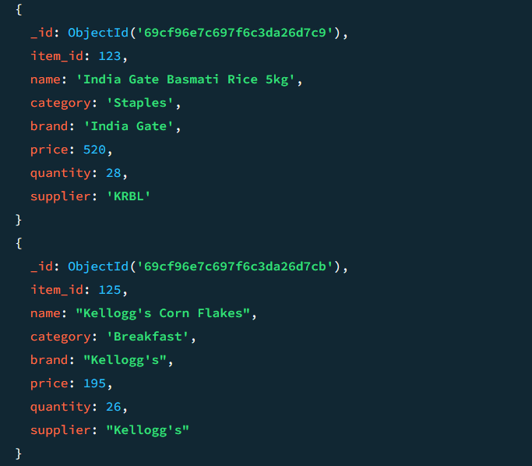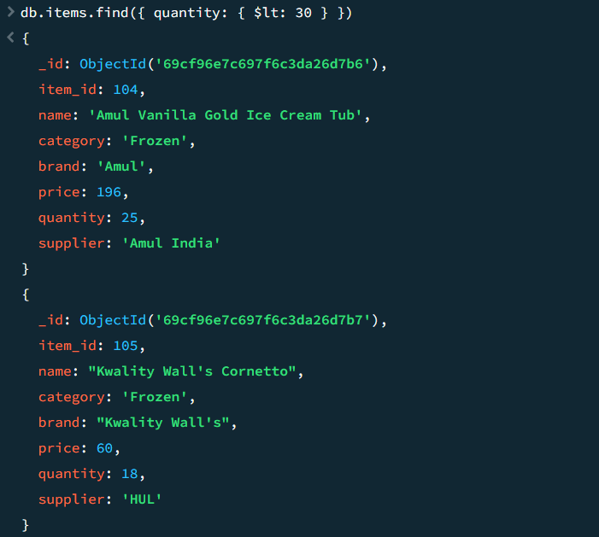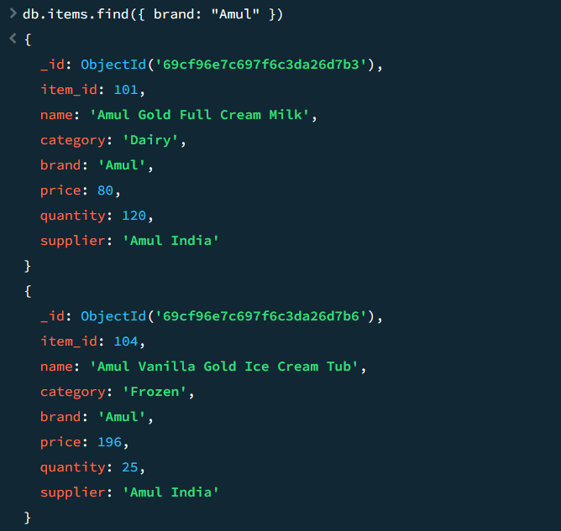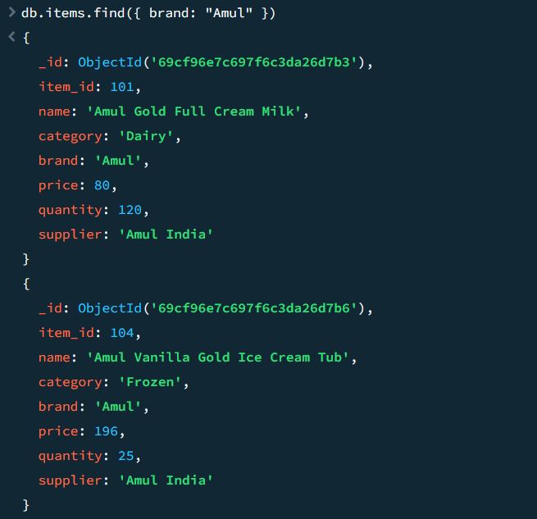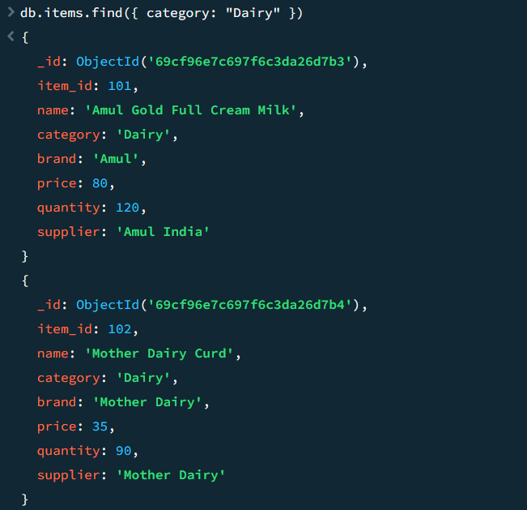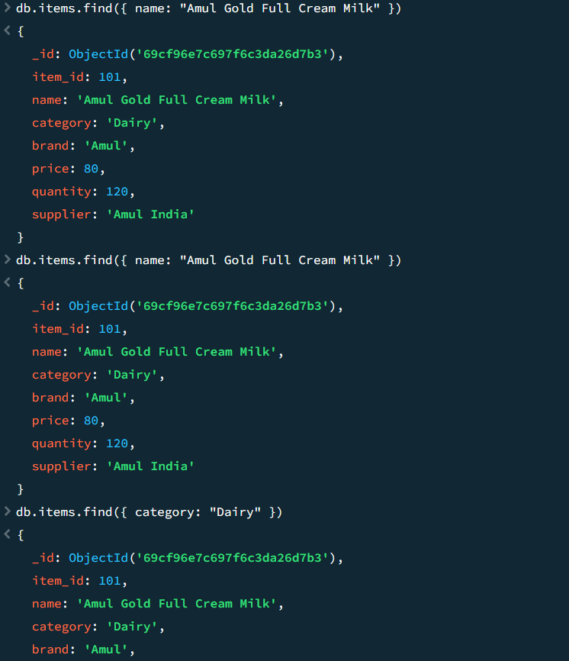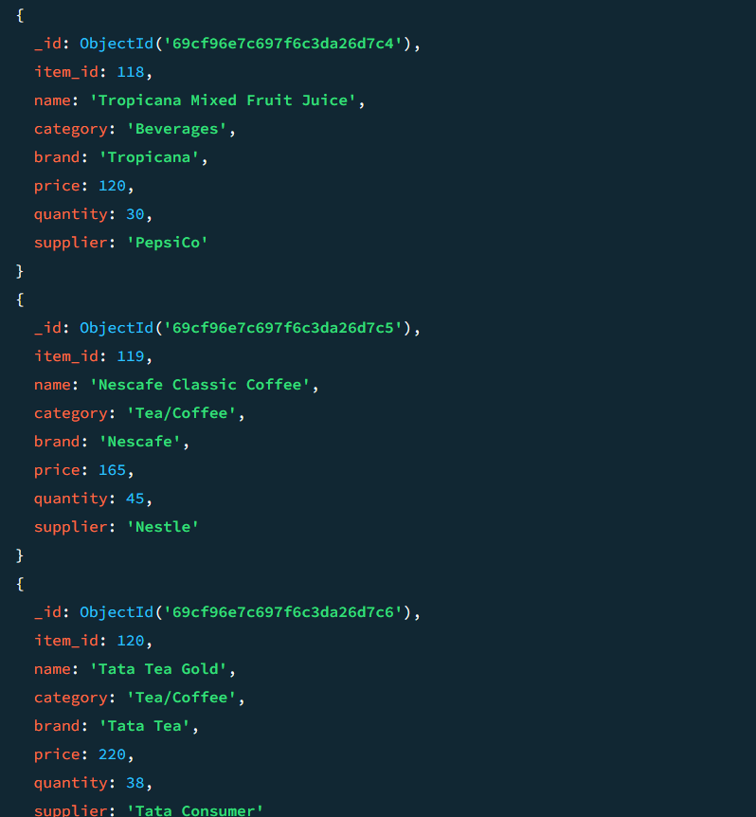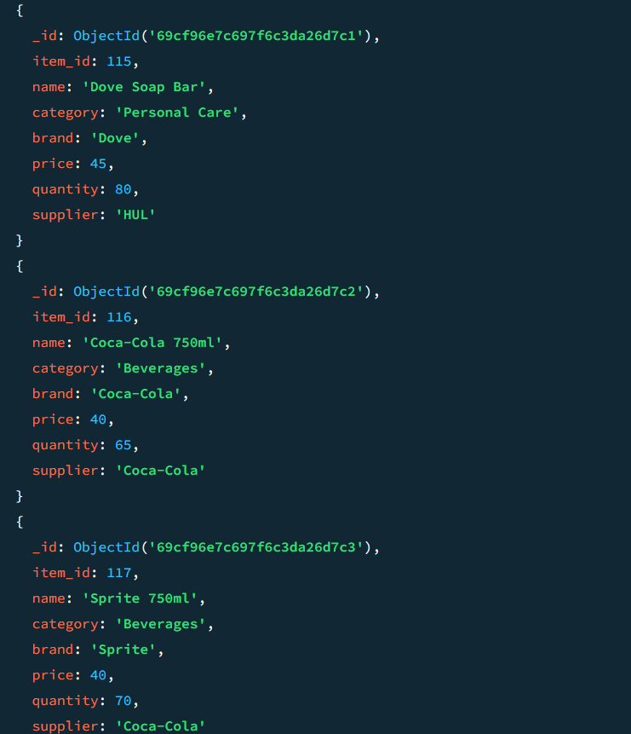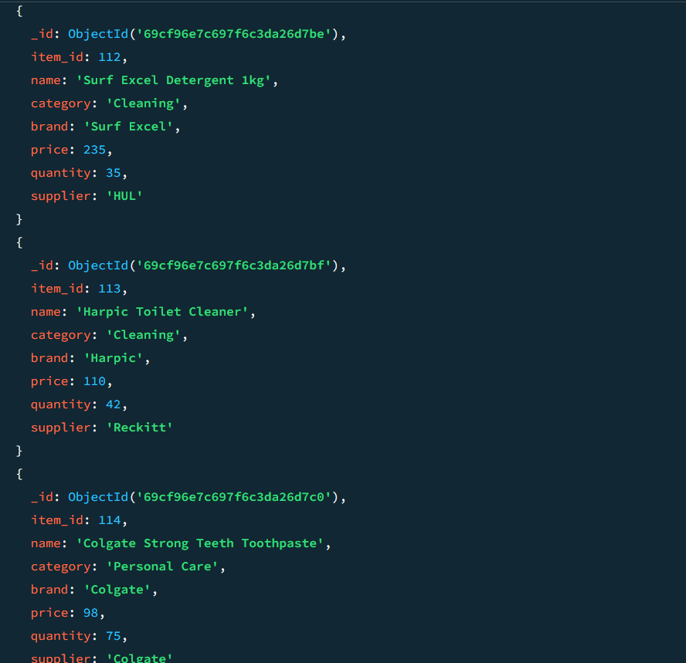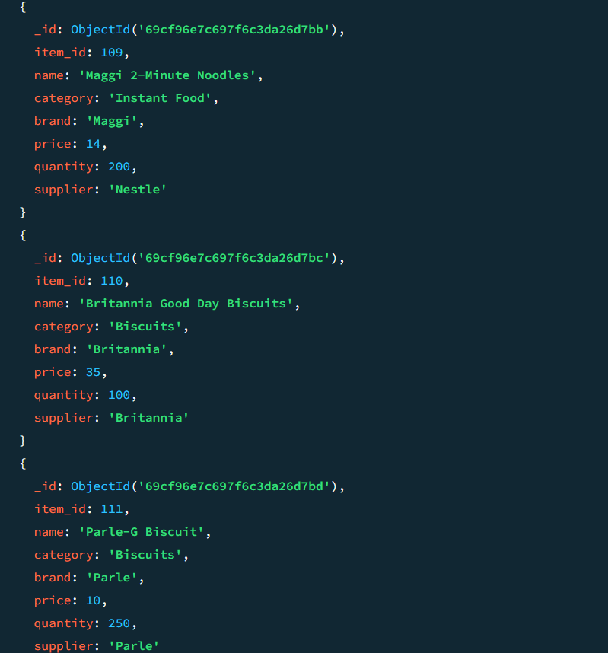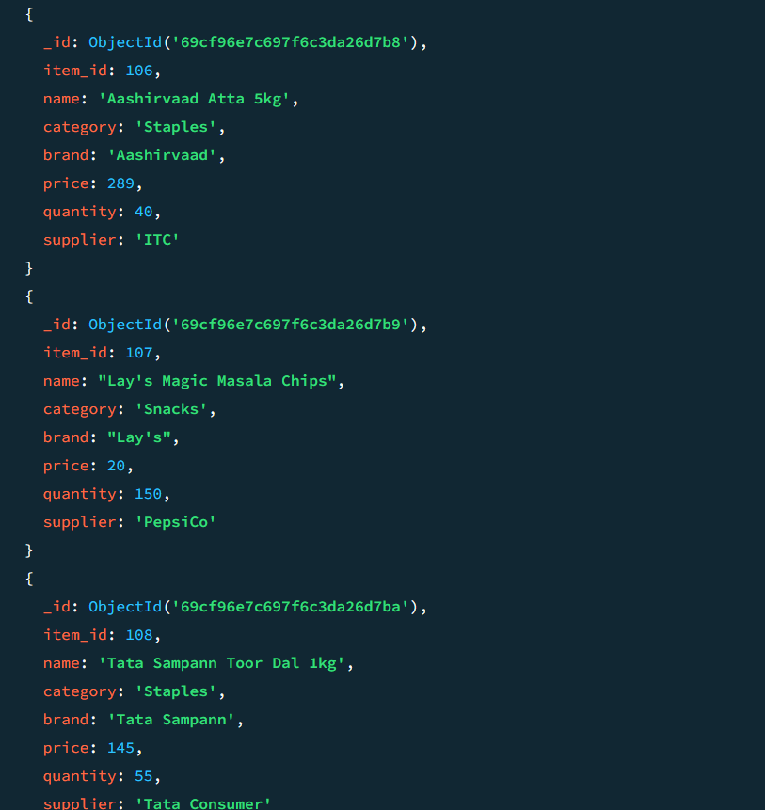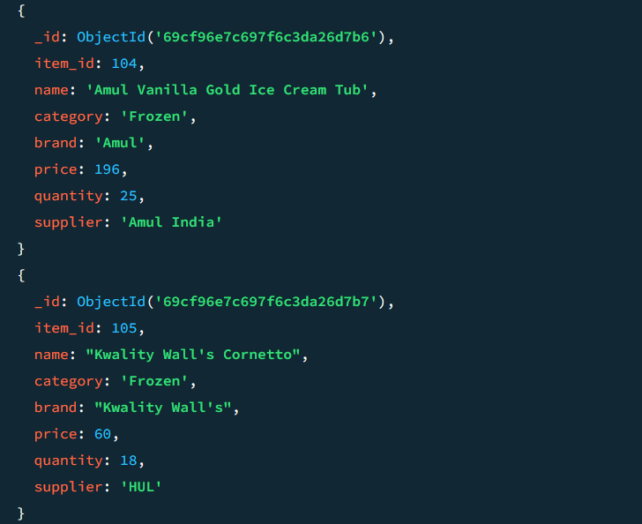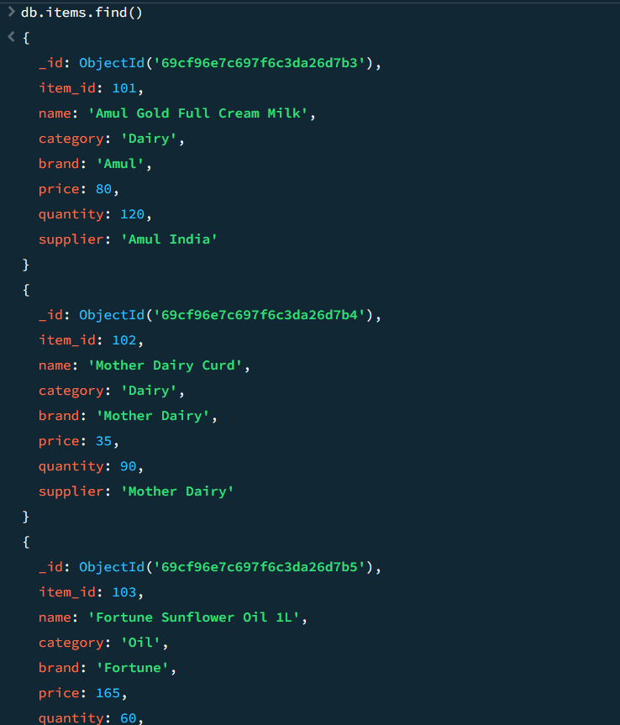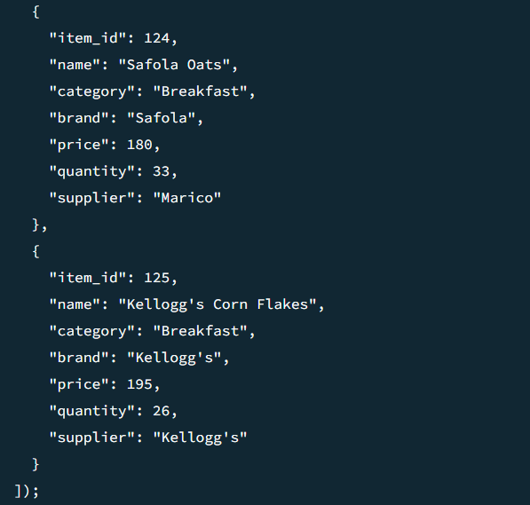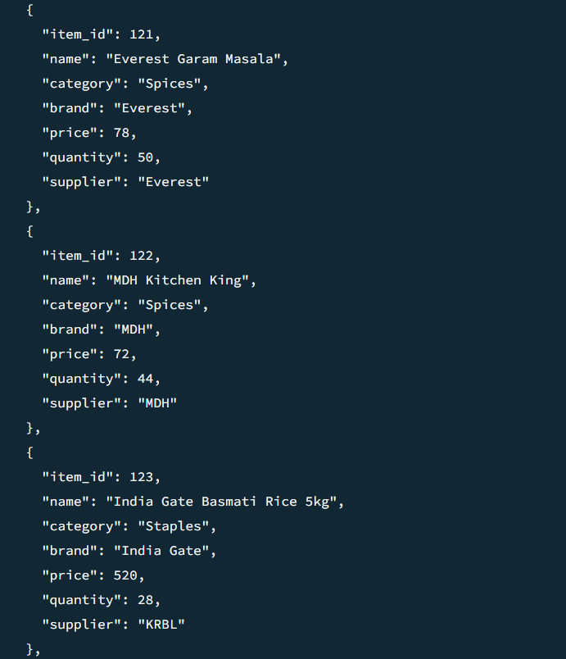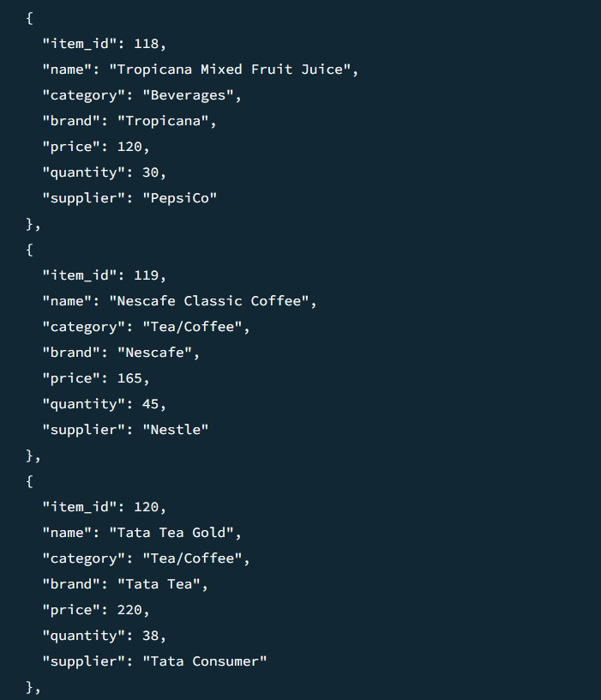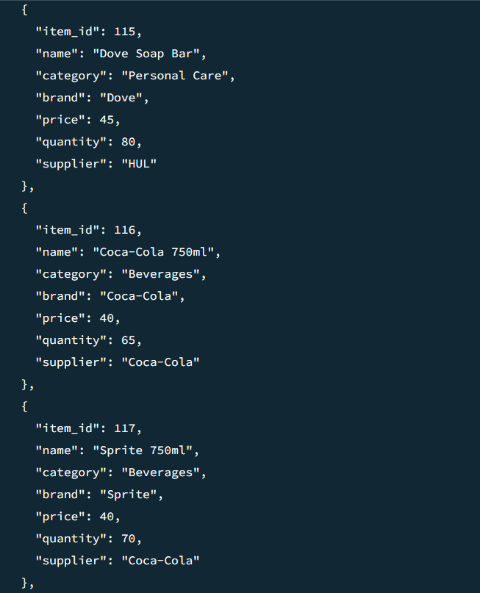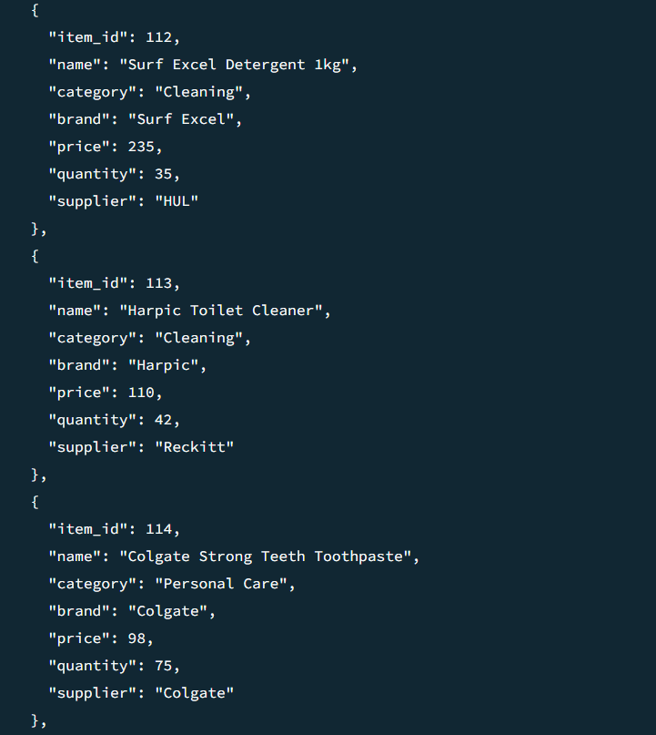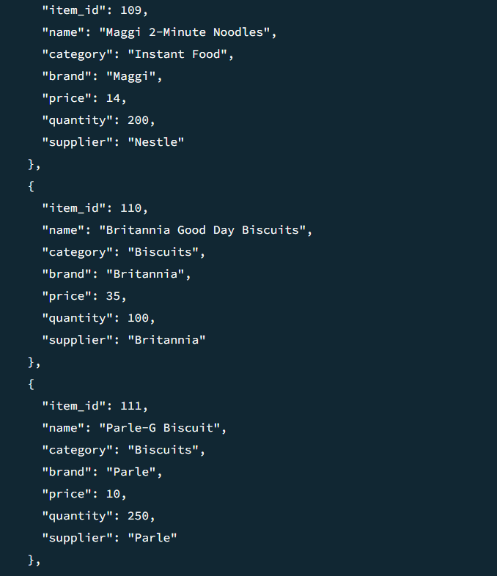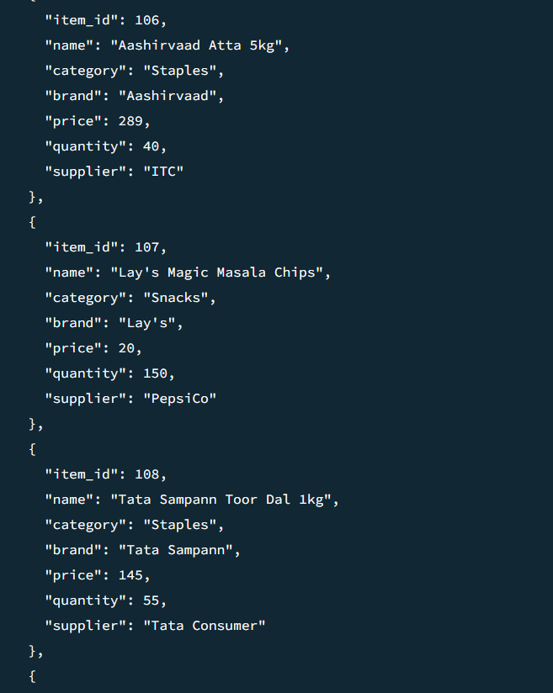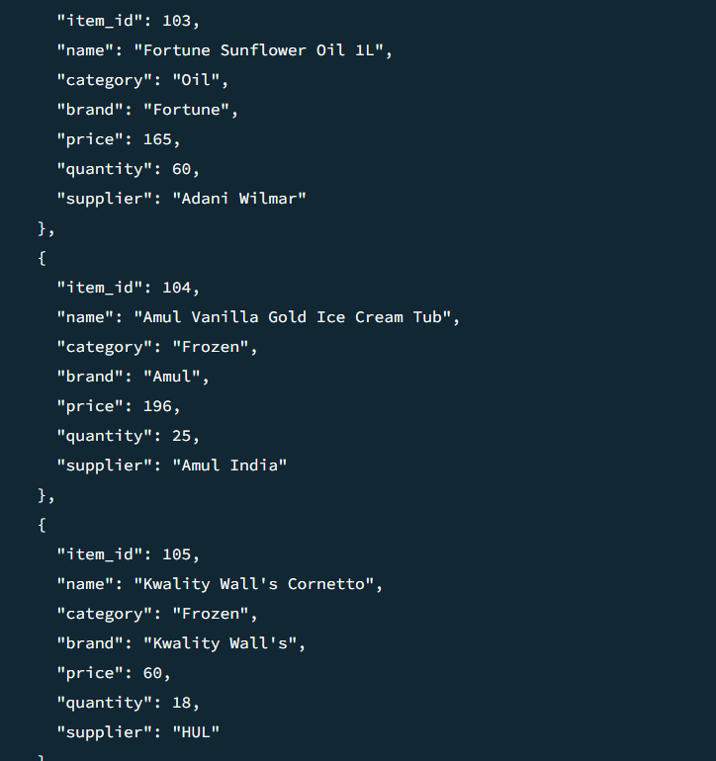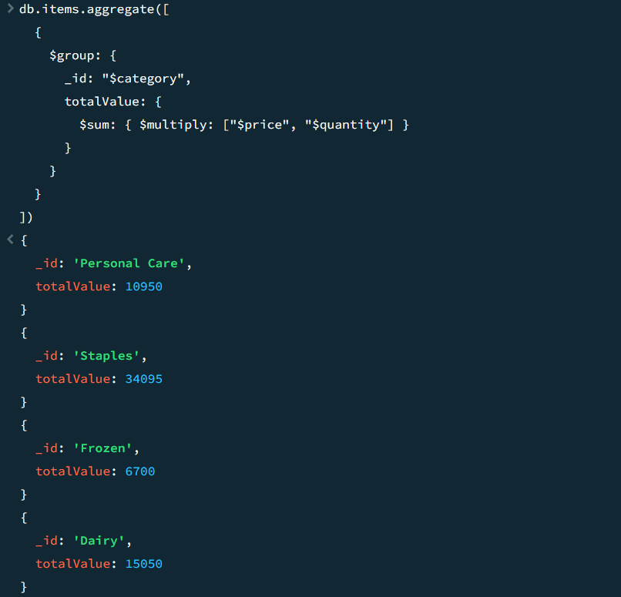
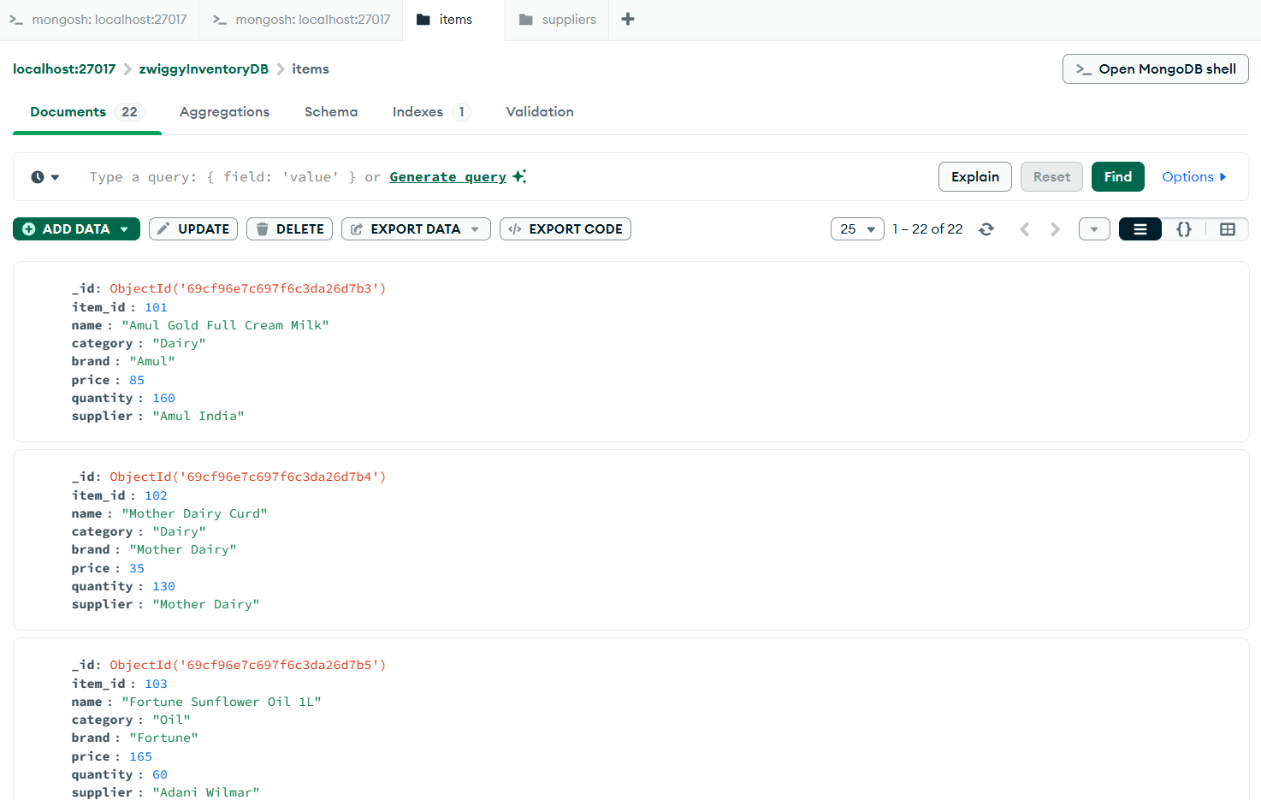
For ‘suppliers’ collection
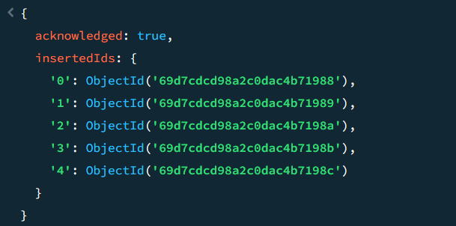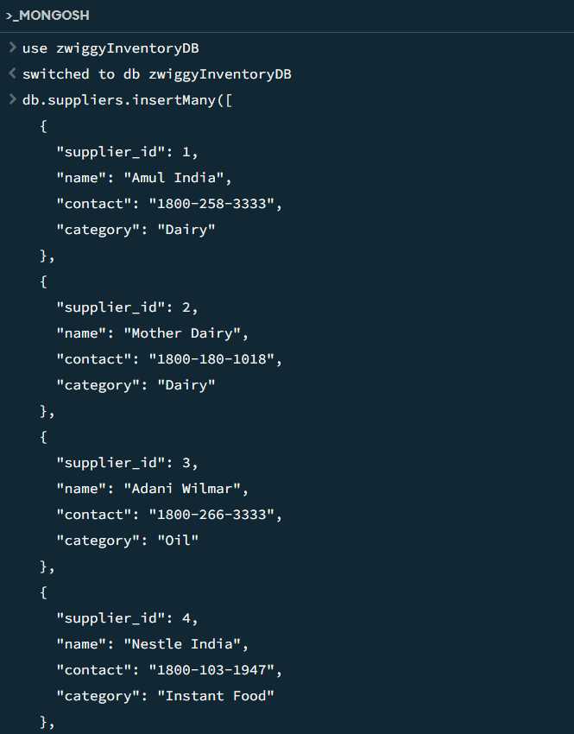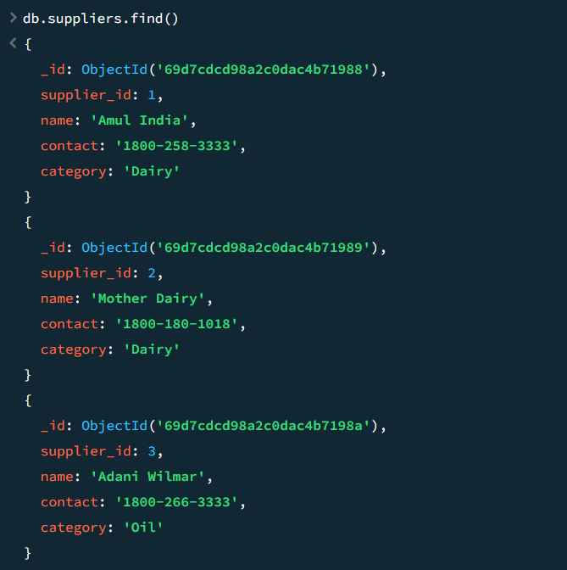
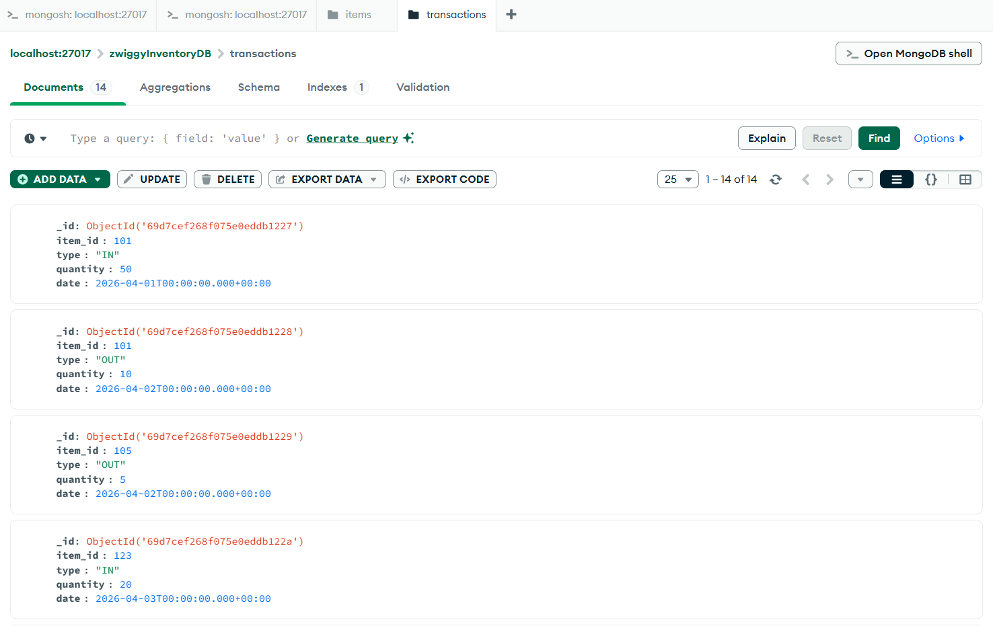
For ‘transactions’ collection
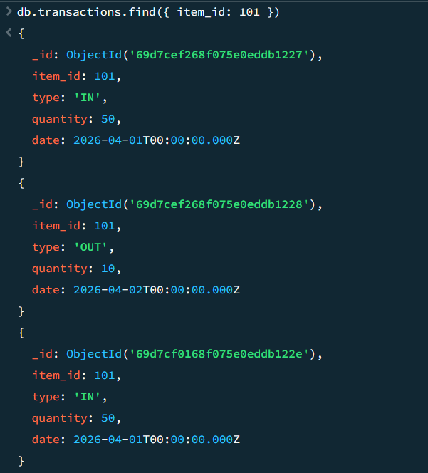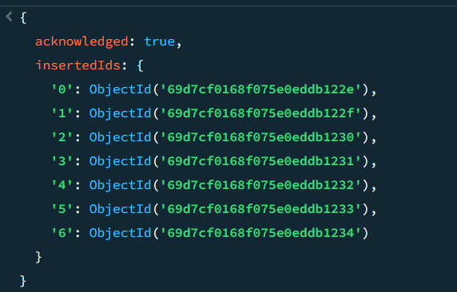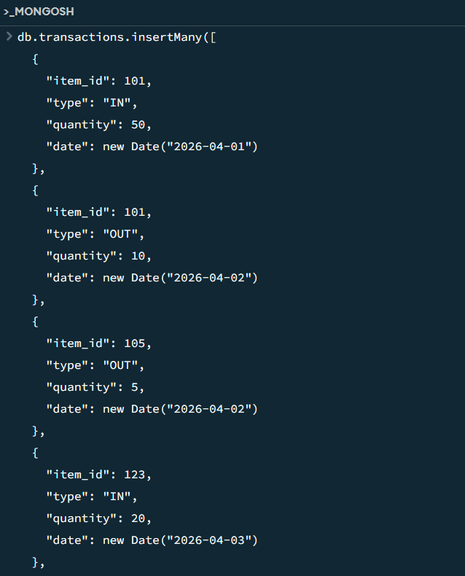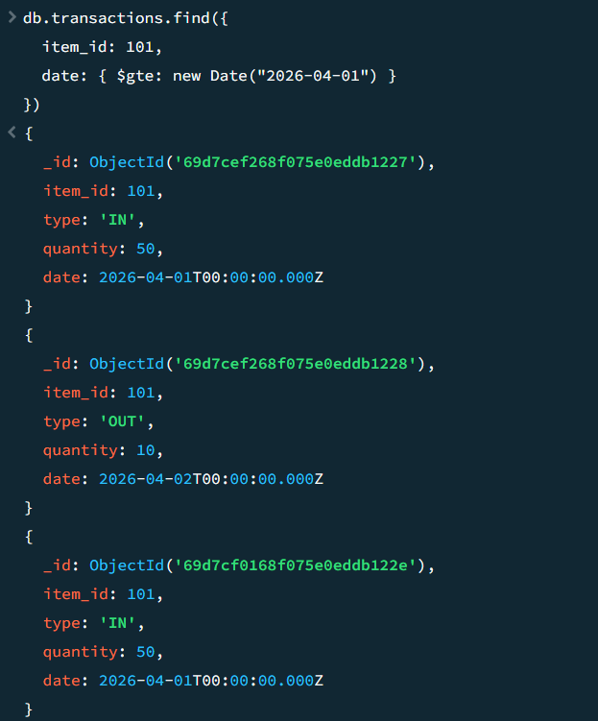
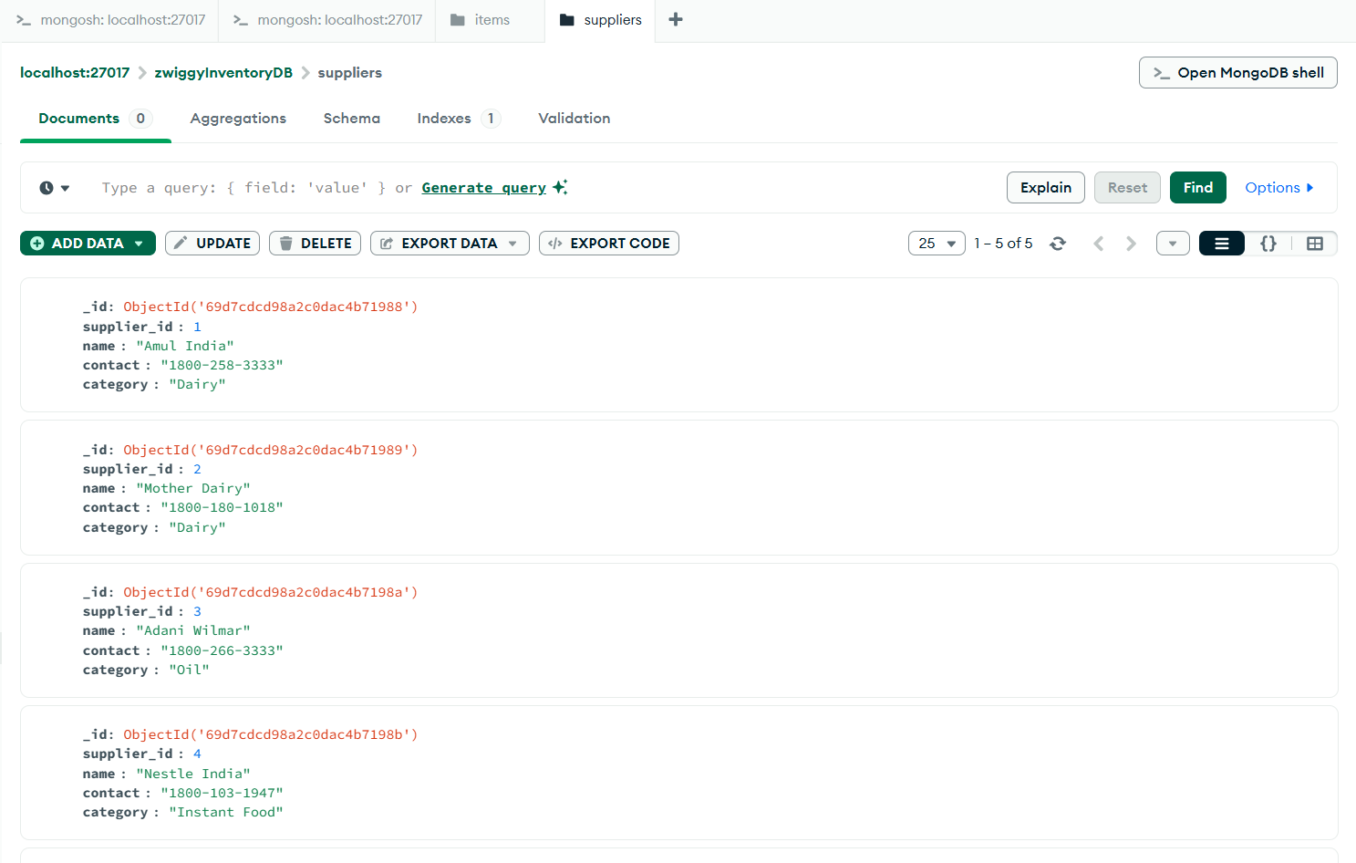
Aggregation
- Low stock report using quantity filter
- Total stock value calculation
- Category-wise stock summary

Indexing
- Single field index on item_id
- Compound index on item_id and date
- Used for faster movement search
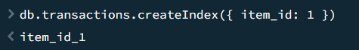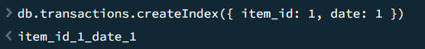
Frontend Dashboard
- Stock overview cards
- Inventory table
- Supplier and transaction forms
Login Page
<!DOCTYPE html>
<html lang="en">
<head>
<meta charset="UTF-8">
<title>Login</title>

<style>

body {
margin: 0;
height: 100vh;

display: flex;
justify-content: center;
align-items: center;

font-family: "Segoe UI", sans-serif;
background: linear-gradient(145deg, #0b3b3c, #0f4c4d);
color: #e6fffa;
}

.login-box {
width: 320px;
padding: 35px 30px;
border-radius: 25px;

background: #0f4c4d;

box-shadow:
10px 10px 25px #062829,
-6px -6px 18px #126061;

display: flex;
flex-direction: column;
align-items: center;
}

/* TITLE */
h2 {
margin-bottom: 25px;
}

.form {
width: 85%;
display: flex;
flex-direction: column;
align-items: center; /* center inputs */
gap: 15px;
}

input {
width: 100%; /* SAME WIDTH */
padding: 12px;
border-radius: 12px;
border: none;

background: #0c4041;
color: white;

box-shadow:
inset 3px 3px 6px #062829,
inset -3px -3px 6px #126061;
}

button {
width: 65%; /* SHORTER THAN INPUT */
padding: 12px;
border-radius: 25px;
border: none;

background: linear-gradient(145deg, #0f4c4d, #0c4041);
color: #e6fffa;

box-shadow:
6px 6px 15px #062829,
-4px -4px 10px #126061;

cursor: pointer;
}

button:active {
box-shadow:
inset 4px 4px 10px #062829,
inset -4px -4px 10px #126061;
}

#error {
margin-top: 10px;
font-size: 13px;
color: #f87171;
text-align: center;
}

</style>
</head>

<body>

<div class="login-box">
<h2>Login</h2>

<div class="form">
<input id="username" placeholder="Username">
<input id="password" type="password" placeholder="Password">
<button onclick="login()">Login</button>
</div>

<div id="error"></div>
</div>

<script>
function login(){
const user = username.value;
const pass = password.value;

if(user === "hehe" && pass === "thisisourprojecthehe"){
window.location.href = "dashboard.html";
} else {
error.innerText = "Invalid credentials";
}
}
</script>

</body>
</html>

Dashboard
<!DOCTYPE html>
<html lang="en">
<head>
<meta charset="UTF-8">
<title>Inventory Dashboard</title>

<style>
body {
margin: 0;
font-family: "Segoe UI", sans-serif;
background: linear-gradient(145deg, #0b3b3c, #0f4c4d);
color: #e6fffa;
}

.navbar {
display: flex;
justify-content: space-between;
margin: 20px;
padding: 12px 25px;
border-radius: 30px;
background: #0f4c4d;
box-shadow: 6px 6px 15px #062829, -4px -4px 10px #126061;
}

.navbar a {
color: #d1fae5;
margin-right: 15px;
cursor: pointer;
font-weight: 500;
}

.container {
display: grid;
grid-template-columns: repeat(2, 1fr);
gap: 25px;
padding: 20px;
}

.full { grid-column: span 2; }

.section {
padding: 30px 20px;
border-radius: 20px;
background: #0f4c4d;
box-shadow: 10px 10px 25px #062829, -6px -6px 18px #126061;
display: flex;
flex-direction: column;
align-items: center;
}

h2 { margin-bottom: 15px; }

.flex {
display: flex;
gap: 15px;
width: 100%;
}

.card {
flex: 1;
padding: 15px;
border-radius: 15px;
background: #0c4041;
box-shadow: inset 3px 3px 8px #062829, inset -3px -3px 8px #126061;
}

.form {
width: 70%;
display: flex;
flex-direction: column;
gap: 12px;
}

input, select {
padding: 12px;
border-radius: 12px;
border: none;
background: #0c4041;
color: white;
box-shadow: inset 3px 3px 6px #062829, inset -3px -3px 6px #126061;
}

button {
width: 60%;
align-self: center;
padding: 12px;
border-radius: 25px;
border: none;
background: linear-gradient(145deg, #0f4c4d, #0c4041);
color: #e6fffa;
font-weight: 500;
box-shadow: 6px 6px 15px #062829, -4px -4px 10px #126061;
cursor: pointer;
transition: 0.2s ease;
}

button:active {
box-shadow: inset 4px 4px 10px #062829, inset -4px -4px 10px #126061;
}

.report-text {
font-size: 13px;
margin-bottom: 10px;
opacity: 0.8;
text-align: center;
}

/* UPDATED INVENTORY TABLE */
.inventory-table {
width: 95%;
margin-top: 15px;
border-collapse: separate;
border-spacing: 0 12px;
}

.inventory-table th {
text-align: left;
padding: 14px 18px;
color: #d1fae5;
font-size: 15px;
font-weight: 600;
}

.inventory-table td {
padding: 16px 18px;
background: #0c4041;
color: #e6fffa;
border-radius: 12px;
box-shadow: inset 2px 2px 5px #062829, inset -2px -2px 5px #126061;
}
</style>
</head>
<body>

<div class="navbar">
<div>
<a onclick="go('overview')">Dashboard</a>
<a onclick="go('inventory')">Inventory</a>
</div>
</div>

<div class="container">
<div id="overview" class="section full">
<h2>Dashboard</h2>
<div class="flex">
<div class="card">Items: <span id="totalItems">0</span></div>
<div class="card">Value: ₹<span id="totalValue">0</span></div>
<div class="card">Low Stock: <span id="lowStock">0</span></div>
</div>
</div>

<div class="section">
<h2>Add Item</h2>
<div class="form">
<input id="name" placeholder="Item Name">
<input id="price" type="number" placeholder="Price">
<input id="quantity" type="number" placeholder="Quantity">
<input id="supplier" placeholder="Supplier">
<button onclick="addItem()">Submit</button>
</div>
</div>

<div class="section">
<h2>Supplier</h2>
<div class="form">
<input id="sname" placeholder="Supplier Name">
<input id="contact" placeholder="Contact">
<button onclick="addSupplier()">Submit</button>
</div>
</div>

<div class="section">
<h2>Transaction</h2>
<div class="form">
<input id="titem" placeholder="Item Name">
<select id="type">
<option value="IN">IN</option>
<option value="OUT">OUT</option>
</select>
<input id="tqty" type="number" placeholder="Quantity">
<button onclick="addTransaction()">Submit</button>
</div>
</div>

<div class="section">
<h2>Reports</h2>
<div class="report-text">Refresh the content to load updated data</div>
<button onclick="loadItems()">Refresh</button>
</div>

<div id="inventory" class="section full">
<h2>Inventory</h2>
<table class="inventory-table">
<thead>
<tr>
<th>Item</th>
<th>Qty</th>
<th>Price</th>
<th>Supplier</th>
</tr>
</thead>
<tbody id="itemsList"></tbody>
</table>
</div>
</div>

<script>
const API = "http://localhost:3000";

function go(id) {
document.getElementById(id).scrollIntoView({ behavior: "smooth" });
}

async function addItem() {
await fetch(API + "/addItem", {
method: "POST",
headers: { "Content-Type": "application/json" },
body: JSON.stringify({
name: name.value,
price: +price.value,
quantity: +quantity.value,
supplier_id: supplier.value
})
});
loadItems();
}

async function addSupplier() {
await fetch(API + "/addSupplier", {
method: "POST",
headers: { "Content-Type": "application/json" },
body: JSON.stringify({
name: sname.value,
contact: contact.value
})
});
}

async function addTransaction() {
await fetch(API + "/transaction", {
method: "POST",
headers: { "Content-Type": "application/json" },
body: JSON.stringify({
item: titem.value,
type: type.value,
quantity: +tqty.value
})
});
loadItems();
}

async function loadItems() {
const res = await fetch(API + "/items");
const data = await res.json();

itemsList.innerHTML = "";
let total = 0, low = 0;

data.forEach(i => {
total += i.price * i.quantity;
if (i.quantity < 20) low++;

itemsList.innerHTML += `
<tr>
<td>${i.name}</td>
<td>${i.quantity}</td>
<td>₹${i.price}</td>
<td>${i.supplier || i.supplier_id || '-'}</td>
</tr>`;
});

totalItems.innerText = data.length;
totalValue.innerText = total;
lowStock.innerText = low;
}

loadItems();
</script>
</body>
</html>

Backend Working
- Node.js handles API requests
- Express routes connect frontend and database
- MongoDB stores all records
Server.js
const express = require("express");
const mongoose = require("mongoose");
const cors = require("cors");

const app = express();
app.use(express.json());
app.use(cors());

/* CONNECT DB */
mongoose.connect("mongodb://127.0.0.1:27017/zwiggyInventoryDB")
.then(()=>console.log("MongoDB Connected"))
.catch(err => console.log(err));

/* SCHEMAS */
const Item = mongoose.model("Item", {
name: String,
price: Number,
quantity: Number,
supplier_id: String
});

const Supplier = mongoose.model("Supplier", {
name: String,
contact: String
});

const Transaction = mongoose.model("Transaction", {
item: String,
type: String,
quantity: Number
});

/* ROUTES */
app.post("/addItem", async (req, res) => {
await Item.create(req.body);
res.send("Item Added");
});

app.get("/items", async (req, res) => {
const items = await Item.find();
res.json(items);
});

app.post("/addSupplier", async (req, res) => {
await Supplier.create(req.body);
res.send("Supplier Added");
});

app.post("/transaction", async (req, res) => {
const { item, type, quantity } = req.body;

const found = await Item.findOne({ name: item });

if (!found) return res.send("Item not found");

if (type === "IN") found.quantity += quantity;
else found.quantity -= quantity;

await found.save();
await Transaction.create(req.body);

res.send("Transaction Done");
});

/* SERVER */
app.listen(3000, () => console.log("Server running on 3000"));
package-lock.json
{
"name": "backend",
"version": "1.0.0",
"lockfileVersion": 3,
"requires": true,
"packages": {
"": {
"name": "backend",
"version": "1.0.0",
"license": "ISC",
"dependencies": {
"cors": "^2.8.6",
"express": "^5.2.1",
"mongoose": "^9.3.3"
}
},
"node_modules/@mongodb-js/saslprep": {
"version": "1.4.6",
"resolved": "https://registry.npmjs.org/@mongodb-js/saslprep/-/saslprep-1.4.6.tgz",
"integrity": "sha512-y+x3H1xBZd38n10NZF/rEBlvDOOMQ6LKUTHqr8R9VkJ+mmQOYtJFxIlkkK8fZrtOiL6VixbOBWMbZGBdal3Z1g==",
"license": "MIT",
"dependencies": {
"sparse-bitfield": "^3.0.3"
}
},
"node_modules/@types/webidl-conversions": {
"version": "7.0.3",
"resolved": "https://registry.npmjs.org/@types/webidl-conversions/-/webidl-conversions-7.0.3.tgz",
"integrity": "sha512-CiJJvcRtIgzadHCYXw7dqEnMNRjhGZlYK05Mj9OyktqV8uVT8fD2BFOB7S1uwBE3Kj2Z+4UyPmFw/Ixgw/LAlA==",
"license": "MIT"
},
"node_modules/@types/whatwg-url": {
"version": "13.0.0",
"resolved": "https://registry.npmjs.org/@types/whatwg-url/-/whatwg-url-13.0.0.tgz",
"integrity": "sha512-N8WXpbE6Wgri7KUSvrmQcqrMllKZ9uxkYWMt+mCSGwNc0Hsw9VQTW7ApqI4XNrx6/SaM2QQJCzMPDEXE058s+Q==",
"license": "MIT",
"dependencies": {
"@types/webidl-conversions": "*"
}
},
"node_modules/accepts": {
"version": "2.0.0",
"resolved": "https://registry.npmjs.org/accepts/-/accepts-2.0.0.tgz",
"integrity": "sha512-5cvg6CtKwfgdmVqY1WIiXKc3Q1bkRqGLi+2W/6ao+6Y7gu/RCwRuAhGEzh5B4KlszSuTLgZYuqFqo5bImjNKng==",
"license": "MIT",
"dependencies": {
"mime-types": "^3.0.0",
"negotiator": "^1.0.0"
},
"engines": {
"node": ">= 0.6"
}
},
"node_modules/body-parser": {
"version": "2.2.2",
"resolved": "https://registry.npmjs.org/body-parser/-/body-parser-2.2.2.tgz",
"integrity": "sha512-oP5VkATKlNwcgvxi0vM0p/D3n2C3EReYVX+DNYs5TjZFn/oQt2j+4sVJtSMr18pdRr8wjTcBl6LoV+FUwzPmNA==",
"license": "MIT",
"dependencies": {
"bytes": "^3.1.2",
"content-type": "^1.0.5",
"debug": "^4.4.3",
"http-errors": "^2.0.0",
"iconv-lite": "^0.7.0",
"on-finished": "^2.4.1",
"qs": "^6.14.1",
"raw-body": "^3.0.1",
"type-is": "^2.0.1"
},
"engines": {
"node": ">=18"
},
"funding": {
"type": "opencollective",
"url": "https://opencollective.com/express"
}
},
"node_modules/bson": {
"version": "7.2.0",
"resolved": "https://registry.npmjs.org/bson/-/bson-7.2.0.tgz",
"integrity": "sha512-YCEo7KjMlbNlyHhz7zAZNDpIpQbd+wOEHJYezv0nMYTn4x31eIUM2yomNNubclAt63dObUzKHWsBLJ9QcZNSnQ==",
"license": "Apache-2.0",
"engines": {
"node": ">=20.19.0"
}
},
"node_modules/bytes": {
"version": "3.1.2",
"resolved": "https://registry.npmjs.org/bytes/-/bytes-3.1.2.tgz",
"integrity": "sha512-/Nf7TyzTx6S3yRJObOAV7956r8cr2+Oj8AC5dt8wSP3BQAoeX58NoHyCU8P8zGkNXStjTSi6fzO6F0pBdcYbEg==",
"license": "MIT",
"engines": {
"node": ">= 0.8"
}
},
"node_modules/call-bind-apply-helpers": {
"version": "1.0.2",
"resolved": "https://registry.npmjs.org/call-bind-apply-helpers/-/call-bind-apply-helpers-1.0.2.tgz",
"integrity": "sha512-Sp1ablJ0ivDkSzjcaJdxEunN5/XvksFJ2sMBFfq6x0ryhQV/2b/KwFe21cMpmHtPOSij8K99/wSfoEuTObmuMQ==",
"license": "MIT",
"dependencies": {
"es-errors": "^1.3.0",
"function-bind": "^1.1.2"
},
"engines": {
"node": ">= 0.4"
}
},
"node_modules/call-bound": {
"version": "1.0.4",
"resolved": "https://registry.npmjs.org/call-bound/-/call-bound-1.0.4.tgz",
"integrity": "sha512-+ys997U96po4Kx/ABpBCqhA9EuxJaQWDQg7295H4hBphv3IZg0boBKuwYpt4YXp6MZ5AmZQnU/tyMTlRpaSejg==",
"license": "MIT",
"dependencies": {
"call-bind-apply-helpers": "^1.0.2",
"get-intrinsic": "^1.3.0"
},
"engines": {
"node": ">= 0.4"
},
"funding": {
"url": "https://github.com/sponsors/ljharb"
}
},
"node_modules/content-disposition": {
"version": "1.0.1",
"resolved": "https://registry.npmjs.org/content-disposition/-/content-disposition-1.0.1.tgz",
"integrity": "sha512-oIXISMynqSqm241k6kcQ5UwttDILMK4BiurCfGEREw6+X9jkkpEe5T9FZaApyLGGOnFuyMWZpdolTXMtvEJ08Q==",
"license": "MIT",
"engines": {
"node": ">=18"
},
"funding": {
"type": "opencollective",
"url": "https://opencollective.com/express"
}
},
"node_modules/content-type": {
"version": "1.0.5",
"resolved": "https://registry.npmjs.org/content-type/-/content-type-1.0.5.tgz",
"integrity": "sha512-nTjqfcBFEipKdXCv4YDQWCfmcLZKm81ldF0pAopTvyrFGVbcR6P/VAAd5G7N+0tTr8QqiU0tFadD6FK4NtJwOA==",
"license": "MIT",
"engines": {
"node": ">= 0.6"
}
},
"node_modules/cookie": {
"version": "0.7.2",
"resolved": "https://registry.npmjs.org/cookie/-/cookie-0.7.2.tgz",
"integrity": "sha512-yki5XnKuf750l50uGTllt6kKILY4nQ1eNIQatoXEByZ5dWgnKqbnqmTrBE5B4N7lrMJKQ2ytWMiTO2o0v6Ew/w==",
"license": "MIT",
"engines": {
"node": ">= 0.6"
}
},
"node_modules/cookie-signature": {
"version": "1.2.2",
"resolved": "https://registry.npmjs.org/cookie-signature/-/cookie-signature-1.2.2.tgz",
"integrity": "sha512-D76uU73ulSXrD1UXF4KE2TMxVVwhsnCgfAyTg9k8P6KGZjlXKrOLe4dJQKI3Bxi5wjesZoFXJWElNWBjPZMbhg==",
"license": "MIT",
"engines": {
"node": ">=6.6.0"
}
},
"node_modules/cors": {
"version": "2.8.6",
"resolved": "https://registry.npmjs.org/cors/-/cors-2.8.6.tgz",
"integrity": "sha512-tJtZBBHA6vjIAaF6EnIaq6laBBP9aq/Y3ouVJjEfoHbRBcHBAHYcMh/w8LDrk2PvIMMq8gmopa5D4V8RmbrxGw==",
"license": "MIT",
"dependencies": {
"object-assign": "^4",
"vary": "^1"
},
"engines": {
"node": ">= 0.10"
},
"funding": {
"type": "opencollective",
"url": "https://opencollective.com/express"
}
},
"node_modules/debug": {
"version": "4.4.3",
"resolved": "https://registry.npmjs.org/debug/-/debug-4.4.3.tgz",
"integrity": "sha512-RGwwWnwQvkVfavKVt22FGLw+xYSdzARwm0ru6DhTVA3umU5hZc28V3kO4stgYryrTlLpuvgI9GiijltAjNbcqA==",
"license": "MIT",
"dependencies": {
"ms": "^2.1.3"
},
"engines": {
"node": ">=6.0"
},
"peerDependenciesMeta": {
"supports-color": {
"optional": true
}
}
},
"node_modules/depd": {
"version": "2.0.0",
"resolved": "https://registry.npmjs.org/depd/-/depd-2.0.0.tgz",
"integrity": "sha512-g7nH6P6dyDioJogAAGprGpCtVImJhpPk/roCzdb3fIh61/s/nPsfR6onyMwkCAR/OlC3yBC0lESvUoQEAssIrw==",
"license": "MIT",
"engines": {
"node": ">= 0.8"
}
},
"node_modules/dunder-proto": {
"version": "1.0.1",
"resolved": "https://registry.npmjs.org/dunder-proto/-/dunder-proto-1.0.1.tgz",
"integrity": "sha512-KIN/nDJBQRcXw0MLVhZE9iQHmG68qAVIBg9CqmUYjmQIhgij9U5MFvrqkUL5FbtyyzZuOeOt0zdeRe4UY7ct+A==",
"license": "MIT",
"dependencies": {
"call-bind-apply-helpers": "^1.0.1",
"es-errors": "^1.3.0",
"gopd": "^1.2.0"
},
"engines": {
"node": ">= 0.4"
}
},
"node_modules/ee-first": {
"version": "1.1.1",
"resolved": "https://registry.npmjs.org/ee-first/-/ee-first-1.1.1.tgz",
"integrity": "sha512-WMwm9LhRUo+WUaRN+vRuETqG89IgZphVSNkdFgeb6sS/E4OrDIN7t48CAewSHXc6C8lefD8KKfr5vY61brQlow==",
"license": "MIT"
},
"node_modules/encodeurl": {
"version": "2.0.0",
"resolved": "https://registry.npmjs.org/encodeurl/-/encodeurl-2.0.0.tgz",
"integrity": "sha512-Q0n9HRi4m6JuGIV1eFlmvJB7ZEVxu93IrMyiMsGC0lrMJMWzRgx6WGquyfQgZVb31vhGgXnfmPNNXmxnOkRBrg==",
"license": "MIT",
"engines": {
"node": ">= 0.8"
}
},
"node_modules/es-define-property": {
"version": "1.0.1",
"resolved": "https://registry.npmjs.org/es-define-property/-/es-define-property-1.0.1.tgz",
"integrity": "sha512-e3nRfgfUZ4rNGL232gUgX06QNyyez04KdjFrF+LTRoOXmrOgFKDg4BCdsjW8EnT69eqdYGmRpJwiPVYNrCaW3g==",
"license": "MIT",
"engines": {
"node": ">= 0.4"
}
},
"node_modules/es-errors": {
"version": "1.3.0",
"resolved": "https://registry.npmjs.org/es-errors/-/es-errors-1.3.0.tgz",
"integrity": "sha512-Zf5H2Kxt2xjTvbJvP2ZWLEICxA6j+hAmMzIlypy4xcBg1vKVnx89Wy0GbS+kf5cwCVFFzdCFh2XSCFNULS6csw==",
"license": "MIT",
"engines": {
"node": ">= 0.4"
}
},
"node_modules/es-object-atoms": {
"version": "1.1.1",
"resolved": "https://registry.npmjs.org/es-object-atoms/-/es-object-atoms-1.1.1.tgz",
"integrity": "sha512-FGgH2h8zKNim9ljj7dankFPcICIK9Cp5bm+c2gQSYePhpaG5+esrLODihIorn+Pe6FGJzWhXQotPv73jTaldXA==",
"license": "MIT",
"dependencies": {
"es-errors": "^1.3.0"
},
"engines": {
"node": ">= 0.4"
}
},
"node_modules/escape-html": {
"version": "1.0.3",
"resolved": "https://registry.npmjs.org/escape-html/-/escape-html-1.0.3.tgz",
"integrity": "sha512-NiSupZ4OeuGwr68lGIeym/ksIZMJodUGOSCZ/FSnTxcrekbvqrgdUxlJOMpijaKZVjAJrWrGs/6Jy8OMuyj9ow==",
"license": "MIT"
},
"node_modules/etag": {
"version": "1.8.1",
"resolved": "https://registry.npmjs.org/etag/-/etag-1.8.1.tgz",
"integrity": "sha512-aIL5Fx7mawVa300al2BnEE4iNvo1qETxLrPI/o05L7z6go7fCw1J6EQmbK4FmJ2AS7kgVF/KEZWufBfdClMcPg==",
"license": "MIT",
"engines": {
"node": ">= 0.6"
}
},
"node_modules/express": {
"version": "5.2.1",
"resolved": "https://registry.npmjs.org/express/-/express-5.2.1.tgz",
"integrity": "sha512-hIS4idWWai69NezIdRt2xFVofaF4j+6INOpJlVOLDO8zXGpUVEVzIYk12UUi2JzjEzWL3IOAxcTubgz9Po0yXw==",
"license": "MIT",
"dependencies": {
"accepts": "^2.0.0",
"body-parser": "^2.2.1",
"content-disposition": "^1.0.0",
"content-type": "^1.0.5",
"cookie": "^0.7.1",
"cookie-signature": "^1.2.1",
"debug": "^4.4.0",
"depd": "^2.0.0",
"encodeurl": "^2.0.0",
"escape-html": "^1.0.3",
"etag": "^1.8.1",
"finalhandler": "^2.1.0",
"fresh": "^2.0.0",
"http-errors": "^2.0.0",
"merge-descriptors": "^2.0.0",
"mime-types": "^3.0.0",
"on-finished": "^2.4.1",
"once": "^1.4.0",
"parseurl": "^1.3.3",
"proxy-addr": "^2.0.7",
"qs": "^6.14.0",
"range-parser": "^1.2.1",
"router": "^2.2.0",
"send": "^1.1.0",
"serve-static": "^2.2.0",
"statuses": "^2.0.1",
"type-is": "^2.0.1",
"vary": "^1.1.2"
},
"engines": {
"node": ">= 18"
},
"funding": {
"type": "opencollective",
"url": "https://opencollective.com/express"
}
},
"node_modules/finalhandler": {
"version": "2.1.1",
"resolved": "https://registry.npmjs.org/finalhandler/-/finalhandler-2.1.1.tgz",
"integrity": "sha512-S8KoZgRZN+a5rNwqTxlZZePjT/4cnm0ROV70LedRHZ0p8u9fRID0hJUZQpkKLzro8LfmC8sx23bY6tVNxv8pQA==",
"license": "MIT",
"dependencies": {
"debug": "^4.4.0",
"encodeurl": "^2.0.0",
"escape-html": "^1.0.3",
"on-finished": "^2.4.1",
"parseurl": "^1.3.3",
"statuses": "^2.0.1"
},
"engines": {
"node": ">= 18.0.0"
},
"funding": {
"type": "opencollective",
"url": "https://opencollective.com/express"
}
},
"node_modules/forwarded": {
"version": "0.2.0",
"resolved": "https://registry.npmjs.org/forwarded/-/forwarded-0.2.0.tgz",
"integrity": "sha512-buRG0fpBtRHSTCOASe6hD258tEubFoRLb4ZNA6NxMVHNw2gOcwHo9wyablzMzOA5z9xA9L1KNjk/Nt6MT9aYow==",
"license": "MIT",
"engines": {
"node": ">= 0.6"
}
},
"node_modules/fresh": {
"version": "2.0.0",
"resolved": "https://registry.npmjs.org/fresh/-/fresh-2.0.0.tgz",
"integrity": "sha512-Rx/WycZ60HOaqLKAi6cHRKKI7zxWbJ31MhntmtwMoaTeF7XFH9hhBp8vITaMidfljRQ6eYWCKkaTK+ykVJHP2A==",
"license": "MIT",
"engines": {
"node": ">= 0.8"
}
},
"node_modules/function-bind": {
"version": "1.1.2",
"resolved": "https://registry.npmjs.org/function-bind/-/function-bind-1.1.2.tgz",
"integrity": "sha512-7XHNxH7qX9xG5mIwxkhumTox/MIRNcOgDrxWsMt2pAr23WHp6MrRlN7FBSFpCpr+oVO0F744iUgR82nJMfG2SA==",
"license": "MIT",
"funding": {
"url": "https://github.com/sponsors/ljharb"
}
},
"node_modules/get-intrinsic": {
"version": "1.3.0",
"resolved": "https://registry.npmjs.org/get-intrinsic/-/get-intrinsic-1.3.0.tgz",
"integrity": "sha512-9fSjSaos/fRIVIp+xSJlE6lfwhES7LNtKaCBIamHsjr2na1BiABJPo0mOjjz8GJDURarmCPGqaiVg5mfjb98CQ==",
"license": "MIT",
"dependencies": {
"call-bind-apply-helpers": "^1.0.2",
"es-define-property": "^1.0.1",
"es-errors": "^1.3.0",
"es-object-atoms": "^1.1.1",
"function-bind": "^1.1.2",
"get-proto": "^1.0.1",
"gopd": "^1.2.0",
"has-symbols": "^1.1.0",
"hasown": "^2.0.2",
"math-intrinsics": "^1.1.0"
},
"engines": {
"node": ">= 0.4"
},
"funding": {
"url": "https://github.com/sponsors/ljharb"
}
},
"node_modules/get-proto": {
"version": "1.0.1",
"resolved": "https://registry.npmjs.org/get-proto/-/get-proto-1.0.1.tgz",
"integrity": "sha512-sTSfBjoXBp89JvIKIefqw7U2CCebsc74kiY6awiGogKtoSGbgjYE/G/+l9sF3MWFPNc9IcoOC4ODfKHfxFmp0g==",
"license": "MIT",
"dependencies": {
"dunder-proto": "^1.0.1",
"es-object-atoms": "^1.0.0"
},
"engines": {
"node": ">= 0.4"
}
},
"node_modules/gopd": {
"version": "1.2.0",
"resolved": "https://registry.npmjs.org/gopd/-/gopd-1.2.0.tgz",
"integrity": "sha512-ZUKRh6/kUFoAiTAtTYPZJ3hw9wNxx+BIBOijnlG9PnrJsCcSjs1wyyD6vJpaYtgnzDrKYRSqf3OO6Rfa93xsRg==",
"license": "MIT",
"engines": {
"node": ">= 0.4"
},
"funding": {
"url": "https://github.com/sponsors/ljharb"
}
},
"node_modules/has-symbols": {
"version": "1.1.0",
"resolved": "https://registry.npmjs.org/has-symbols/-/has-symbols-1.1.0.tgz",
"integrity": "sha512-1cDNdwJ2Jaohmb3sg4OmKaMBwuC48sYni5HUw2DvsC8LjGTLK9h+eb1X6RyuOHe4hT0ULCW68iomhjUoKUqlPQ==",
"license": "MIT",
"engines": {
"node": ">= 0.4"
},
"funding": {
"url": "https://github.com/sponsors/ljharb"
}
},
"node_modules/hasown": {
"version": "2.0.2",
"resolved": "https://registry.npmjs.org/hasown/-/hasown-2.0.2.tgz",
"integrity": "sha512-0hJU9SCPvmMzIBdZFqNPXWa6dqh7WdH0cII9y+CyS8rG3nL48Bclra9HmKhVVUHyPWNH5Y7xDwAB7bfgSjkUMQ==",
"license": "MIT",
"dependencies": {
"function-bind": "^1.1.2"
},
"engines": {
"node": ">= 0.4"
}
},
"node_modules/http-errors": {
"version": "2.0.1",
"resolved": "https://registry.npmjs.org/http-errors/-/http-errors-2.0.1.tgz",
"integrity": "sha512-4FbRdAX+bSdmo4AUFuS0WNiPz8NgFt+r8ThgNWmlrjQjt1Q7ZR9+zTlce2859x4KSXrwIsaeTqDoKQmtP8pLmQ==",
"license": "MIT",
"dependencies": {
"depd": "~2.0.0",
"inherits": "~2.0.4",
"setprototypeof": "~1.2.0",
"statuses": "~2.0.2",
"toidentifier": "~1.0.1"
},
"engines": {
"node": ">= 0.8"
},
"funding": {
"type": "opencollective",
"url": "https://opencollective.com/express"
}
},
"node_modules/iconv-lite": {
"version": "0.7.2",
"resolved": "https://registry.npmjs.org/iconv-lite/-/iconv-lite-0.7.2.tgz",
"integrity": "sha512-im9DjEDQ55s9fL4EYzOAv0yMqmMBSZp6G0VvFyTMPKWxiSBHUj9NW/qqLmXUwXrrM7AvqSlTCfvqRb0cM8yYqw==",
"license": "MIT",
"dependencies": {
"safer-buffer": ">= 2.1.2 < 3.0.0"
},
"engines": {
"node": ">=0.10.0"
},
"funding": {
"type": "opencollective",
"url": "https://opencollective.com/express"
}
},
"node_modules/inherits": {
"version": "2.0.4",
"resolved": "https://registry.npmjs.org/inherits/-/inherits-2.0.4.tgz",
"integrity": "sha512-k/vGaX4/Yla3WzyMCvTQOXYeIHvqOKtnqBduzTHpzpQZzAskKMhZ2K+EnBiSM9zGSoIFeMpXKxa4dYeZIQqewQ==",
"license": "ISC"
},
"node_modules/ipaddr.js": {
"version": "1.9.1",
"resolved": "https://registry.npmjs.org/ipaddr.js/-/ipaddr.js-1.9.1.tgz",
"integrity": "sha512-0KI/607xoxSToH7GjN1FfSbLoU0+btTicjsQSWQlh/hZykN8KpmMf7uYwPW3R+akZ6R/w18ZlXSHBYXiYUPO3g==",
"license": "MIT",
"engines": {
"node": ">= 0.10"
}
},
"node_modules/is-promise": {
"version": "4.0.0",
"resolved": "https://registry.npmjs.org/is-promise/-/is-promise-4.0.0.tgz",
"integrity": "sha512-hvpoI6korhJMnej285dSg6nu1+e6uxs7zG3BYAm5byqDsgJNWwxzM6z6iZiAgQR4TJ30JmBTOwqZUw3WlyH3AQ==",
"license": "MIT"
},
"node_modules/kareem": {
"version": "3.2.0",
"resolved": "https://registry.npmjs.org/kareem/-/kareem-3.2.0.tgz",
"integrity": "sha512-VS8MWZz/cT+SqBCpVfNN4zoVz5VskR3N4+sTmUXme55e9avQHntpwpNq0yjnosISXqwJ3AQVjlbI4Dyzv//JtA==",
"license": "Apache-2.0",
"engines": {
"node": ">=18.0.0"
}
},
"node_modules/math-intrinsics": {
"version": "1.1.0",
"resolved": "https://registry.npmjs.org/math-intrinsics/-/math-intrinsics-1.1.0.tgz",
"integrity": "sha512-/IXtbwEk5HTPyEwyKX6hGkYXxM9nbj64B+ilVJnC/R6B0pH5G4V3b0pVbL7DBj4tkhBAppbQUlf6F6Xl9LHu1g==",
"license": "MIT",
"engines": {
"node": ">= 0.4"
}
},
"node_modules/media-typer": {
"version": "1.1.0",
"resolved": "https://registry.npmjs.org/media-typer/-/media-typer-1.1.0.tgz",
"integrity": "sha512-aisnrDP4GNe06UcKFnV5bfMNPBUw4jsLGaWwWfnH3v02GnBuXX2MCVn5RbrWo0j3pczUilYblq7fQ7Nw2t5XKw==",
"license": "MIT",
"engines": {
"node": ">= 0.8"
}
},
"node_modules/memory-pager": {
"version": "1.5.0",
"resolved": "https://registry.npmjs.org/memory-pager/-/memory-pager-1.5.0.tgz",
"integrity": "sha512-ZS4Bp4r/Zoeq6+NLJpP+0Zzm0pR8whtGPf1XExKLJBAczGMnSi3It14OiNCStjQjM6NU1okjQGSxgEZN8eBYKg==",
"license": "MIT"
},
"node_modules/merge-descriptors": {
"version": "2.0.0",
"resolved": "https://registry.npmjs.org/merge-descriptors/-/merge-descriptors-2.0.0.tgz",
"integrity": "sha512-Snk314V5ayFLhp3fkUREub6WtjBfPdCPY1Ln8/8munuLuiYhsABgBVWsozAG+MWMbVEvcdcpbi9R7ww22l9Q3g==",
"license": "MIT",
"engines": {
"node": ">=18"
},
"funding": {
"url": "https://github.com/sponsors/sindresorhus"
}
},
"node_modules/mime-db": {
"version": "1.54.0",
"resolved": "https://registry.npmjs.org/mime-db/-/mime-db-1.54.0.tgz",
"integrity": "sha512-aU5EJuIN2WDemCcAp2vFBfp/m4EAhWJnUNSSw0ixs7/kXbd6Pg64EmwJkNdFhB8aWt1sH2CTXrLxo/iAGV3oPQ==",
"license": "MIT",
"engines": {
"node": ">= 0.6"
}
},
"node_modules/mime-types": {
"version": "3.0.2",
"resolved": "https://registry.npmjs.org/mime-types/-/mime-types-3.0.2.tgz",
"integrity": "sha512-Lbgzdk0h4juoQ9fCKXW4by0UJqj+nOOrI9MJ1sSj4nI8aI2eo1qmvQEie4VD1glsS250n15LsWsYtCugiStS5A==",
"license": "MIT",
"dependencies": {
"mime-db": "^1.54.0"
},
"engines": {
"node": ">=18"
},
"funding": {
"type": "opencollective",
"url": "https://opencollective.com/express"
}
},
"node_modules/mongodb": {
"version": "7.1.1",
"resolved": "https://registry.npmjs.org/mongodb/-/mongodb-7.1.1.tgz",
"integrity": "sha512-067DXiMjcpYQl6bGjWQoTUEE9UoRViTtKFcoqX7z08I+iDZv/emH1g8XEFiO3qiDfXAheT5ozl1VffDTKhIW/w==",
"license": "Apache-2.0",
"dependencies": {
"@mongodb-js/saslprep": "^1.3.0",
"bson": "^7.1.1",
"mongodb-connection-string-url": "^7.0.0"
},
"engines": {
"node": ">=20.19.0"
},
"peerDependencies": {
"@aws-sdk/credential-providers": "^3.806.0",
"@mongodb-js/zstd": "^7.0.0",
"gcp-metadata": "^7.0.1",
"kerberos": "^7.0.0",
"mongodb-client-encryption": ">=7.0.0 <7.1.0",
"snappy": "^7.3.2",
"socks": "^2.8.6"
},
"peerDependenciesMeta": {
"@aws-sdk/credential-providers": {
"optional": true
},
"@mongodb-js/zstd": {
"optional": true
},
"gcp-metadata": {
"optional": true
},
"kerberos": {
"optional": true
},
"mongodb-client-encryption": {
"optional": true
},
"snappy": {
"optional": true
},
"socks": {
"optional": true
}
}
},
"node_modules/mongodb-connection-string-url": {
"version": "7.0.1",
"resolved": "https://registry.npmjs.org/mongodb-connection-string-url/-/mongodb-connection-string-url-7.0.1.tgz",
"integrity": "sha512-h0AZ9A7IDVwwHyMxmdMXKy+9oNlF0zFoahHiX3vQ8e3KFcSP3VmsmfvtRSuLPxmyv2vjIDxqty8smTgie/SNRQ==",
"license": "Apache-2.0",
"dependencies": {
"@types/whatwg-url": "^13.0.0",
"whatwg-url": "^14.1.0"
},
"engines": {
"node": ">=20.19.0"
}
},
"node_modules/mongoose": {
"version": "9.3.3",
"resolved": "https://registry.npmjs.org/mongoose/-/mongoose-9.3.3.tgz",
"integrity": "sha512-sfv5LOIPWeN5o/281kp4Rx9ZnuXb0g8CtvBTi7trYQs2PYYx8LWXegXxG3ar7VEns1o+d4h9LI/Dtc7dTTyYmA==",
"license": "MIT",
"dependencies": {
"kareem": "3.2.0",
"mongodb": "~7.1",
"mpath": "0.9.0",
"mquery": "6.0.0",
"ms": "2.1.3",
"sift": "17.1.3"
},
"engines": {
"node": ">=20.19.0"
},
"funding": {
"type": "opencollective",
"url": "https://opencollective.com/mongoose"
}
},
"node_modules/mpath": {
"version": "0.9.0",
"resolved": "https://registry.npmjs.org/mpath/-/mpath-0.9.0.tgz",
"integrity": "sha512-ikJRQTk8hw5DEoFVxHG1Gn9T/xcjtdnOKIU1JTmGjZZlg9LST2mBLmcX3/ICIbgJydT2GOc15RnNy5mHmzfSew==",
"license": "MIT",
"engines": {
"node": ">=4.0.0"
}
},
"node_modules/mquery": {
"version": "6.0.0",
"resolved": "https://registry.npmjs.org/mquery/-/mquery-6.0.0.tgz",
"integrity": "sha512-b2KQNsmgtkscfeDgkYMcWGn9vZI9YoXh802VDEwE6qc50zxBFQ0Oo8ROkawbPAsXCY1/Z1yp0MagqsZStPWJjw==",
"license": "MIT",
"engines": {
"node": ">=20.19.0"
}
},
"node_modules/ms": {
"version": "2.1.3",
"resolved": "https://registry.npmjs.org/ms/-/ms-2.1.3.tgz",
"integrity": "sha512-6FlzubTLZG3J2a/NVCAleEhjzq5oxgHyaCU9yYXvcLsvoVaHJq/s5xXI6/XXP6tz7R9xAOtHnSO/tXtF3WRTlA==",
"license": "MIT"
},
"node_modules/negotiator": {
"version": "1.0.0",
"resolved": "https://registry.npmjs.org/negotiator/-/negotiator-1.0.0.tgz",
"integrity": "sha512-8Ofs/AUQh8MaEcrlq5xOX0CQ9ypTF5dl78mjlMNfOK08fzpgTHQRQPBxcPlEtIw0yRpws+Zo/3r+5WRby7u3Gg==",
"license": "MIT",
"engines": {
"node": ">= 0.6"
}
},
"node_modules/object-assign": {
"version": "4.1.1",
"resolved": "https://registry.npmjs.org/object-assign/-/object-assign-4.1.1.tgz",
"integrity": "sha512-rJgTQnkUnH1sFw8yT6VSU3zD3sWmu6sZhIseY8VX+GRu3P6F7Fu+JNDoXfklElbLJSnc3FUQHVe4cU5hj+BcUg==",
"license": "MIT",
"engines": {
"node": ">=0.10.0"
}
},
"node_modules/object-inspect": {
"version": "1.13.4",
"resolved": "https://registry.npmjs.org/object-inspect/-/object-inspect-1.13.4.tgz",
"integrity": "sha512-W67iLl4J2EXEGTbfeHCffrjDfitvLANg0UlX3wFUUSTx92KXRFegMHUVgSqE+wvhAbi4WqjGg9czysTV2Epbew==",
"license": "MIT",
"engines": {
"node": ">= 0.4"
},
"funding": {
"url": "https://github.com/sponsors/ljharb"
}
},
"node_modules/on-finished": {
"version": "2.4.1",
"resolved": "https://registry.npmjs.org/on-finished/-/on-finished-2.4.1.tgz",
"integrity": "sha512-oVlzkg3ENAhCk2zdv7IJwd/QUD4z2RxRwpkcGY8psCVcCYZNq4wYnVWALHM+brtuJjePWiYF/ClmuDr8Ch5+kg==",
"license": "MIT",
"dependencies": {
"ee-first": "1.1.1"
},
"engines": {
"node": ">= 0.8"
}
},
"node_modules/once": {
"version": "1.4.0",
"resolved": "https://registry.npmjs.org/once/-/once-1.4.0.tgz",
"integrity": "sha512-lNaJgI+2Q5URQBkccEKHTQOPaXdUxnZZElQTZY0MFUAuaEqe1E+Nyvgdz/aIyNi6Z9MzO5dv1H8n58/GELp3+w==",
"license": "ISC",
"dependencies": {
"wrappy": "1"
}
},
"node_modules/parseurl": {
"version": "1.3.3",
"resolved": "https://registry.npmjs.org/parseurl/-/parseurl-1.3.3.tgz",
"integrity": "sha512-CiyeOxFT/JZyN5m0z9PfXw4SCBJ6Sygz1Dpl0wqjlhDEGGBP1GnsUVEL0p63hoG1fcj3fHynXi9NYO4nWOL+qQ==",
"license": "MIT",
"engines": {
"node": ">= 0.8"
}
},
"node_modules/path-to-regexp": {
"version": "8.4.0",
"resolved": "https://registry.npmjs.org/path-to-regexp/-/path-to-regexp-8.4.0.tgz",
"integrity": "sha512-PuseHIvAnz3bjrM2rGJtSgo1zjgxapTLZ7x2pjhzWwlp4SJQgK3f3iZIQwkpEnBaKz6seKBADpM4B4ySkuYypg==",
"license": "MIT",
"funding": {
"type": "opencollective",
"url": "https://opencollective.com/express"
}
},
"node_modules/proxy-addr": {
"version": "2.0.7",
"resolved": "https://registry.npmjs.org/proxy-addr/-/proxy-addr-2.0.7.tgz",
"integrity": "sha512-llQsMLSUDUPT44jdrU/O37qlnifitDP+ZwrmmZcoSKyLKvtZxpyV0n2/bD/N4tBAAZ/gJEdZU7KMraoK1+XYAg==",
"license": "MIT",
"dependencies": {
"forwarded": "0.2.0",
"ipaddr.js": "1.9.1"
},
"engines": {
"node": ">= 0.10"
}
},
"node_modules/punycode": {
"version": "2.3.1",
"resolved": "https://registry.npmjs.org/punycode/-/punycode-2.3.1.tgz",
"integrity": "sha512-vYt7UD1U9Wg6138shLtLOvdAu+8DsC/ilFtEVHcH+wydcSpNE20AfSOduf6MkRFahL5FY7X1oU7nKVZFtfq8Fg==",
"license": "MIT",
"engines": {
"node": ">=6"
}
},
"node_modules/qs": {
"version": "6.15.0",
"resolved": "https://registry.npmjs.org/qs/-/qs-6.15.0.tgz",
"integrity": "sha512-mAZTtNCeetKMH+pSjrb76NAM8V9a05I9aBZOHztWy/UqcJdQYNsf59vrRKWnojAT9Y+GbIvoTBC++CPHqpDBhQ==",
"license": "BSD-3-Clause",
"dependencies": {
"side-channel": "^1.1.0"
},
"engines": {
"node": ">=0.6"
},
"funding": {
"url": "https://github.com/sponsors/ljharb"
}
},
"node_modules/range-parser": {
"version": "1.2.1",
"resolved": "https://registry.npmjs.org/range-parser/-/range-parser-1.2.1.tgz",
"integrity": "sha512-Hrgsx+orqoygnmhFbKaHE6c296J+HTAQXoxEF6gNupROmmGJRoyzfG3ccAveqCBrwr/2yxQ5BVd/GTl5agOwSg==",
"license": "MIT",
"engines": {
"node": ">= 0.6"
}
},
"node_modules/raw-body": {
"version": "3.0.2",
"resolved": "https://registry.npmjs.org/raw-body/-/raw-body-3.0.2.tgz",
"integrity": "sha512-K5zQjDllxWkf7Z5xJdV0/B0WTNqx6vxG70zJE4N0kBs4LovmEYWJzQGxC9bS9RAKu3bgM40lrd5zoLJ12MQ5BA==",
"license": "MIT",
"dependencies": {
"bytes": "~3.1.2",
"http-errors": "~2.0.1",
"iconv-lite": "~0.7.0",
"unpipe": "~1.0.0"
},
"engines": {
"node": ">= 0.10"
}
},
"node_modules/router": {
"version": "2.2.0",
"resolved": "https://registry.npmjs.org/router/-/router-2.2.0.tgz",
"integrity": "sha512-nLTrUKm2UyiL7rlhapu/Zl45FwNgkZGaCpZbIHajDYgwlJCOzLSk+cIPAnsEqV955GjILJnKbdQC1nVPz+gAYQ==",
"license": "MIT",
"dependencies": {
"debug": "^4.4.0",
"depd": "^2.0.0",
"is-promise": "^4.0.0",
"parseurl": "^1.3.3",
"path-to-regexp": "^8.0.0"
},
"engines": {
"node": ">= 18"
}
},
"node_modules/safer-buffer": {
"version": "2.1.2",
"resolved": "https://registry.npmjs.org/safer-buffer/-/safer-buffer-2.1.2.tgz",
"integrity": "sha512-YZo3K82SD7Riyi0E1EQPojLz7kpepnSQI9IyPbHHg1XXXevb5dJI7tpyN2ADxGcQbHG7vcyRHk0cbwqcQriUtg==",
"license": "MIT"
},
"node_modules/send": {
"version": "1.2.1",
"resolved": "https://registry.npmjs.org/send/-/send-1.2.1.tgz",
"integrity": "sha512-1gnZf7DFcoIcajTjTwjwuDjzuz4PPcY2StKPlsGAQ1+YH20IRVrBaXSWmdjowTJ6u8Rc01PoYOGHXfP1mYcZNQ==",
"license": "MIT",
"dependencies": {
"debug": "^4.4.3",
"encodeurl": "^2.0.0",
"escape-html": "^1.0.3",
"etag": "^1.8.1",
"fresh": "^2.0.0",
"http-errors": "^2.0.1",
"mime-types": "^3.0.2",
"ms": "^2.1.3",
"on-finished": "^2.4.1",
"range-parser": "^1.2.1",
"statuses": "^2.0.2"
},
"engines": {
"node": ">= 18"
},
"funding": {
"type": "opencollective",
"url": "https://opencollective.com/express"
}
},
"node_modules/serve-static": {
"version": "2.2.1",
"resolved": "https://registry.npmjs.org/serve-static/-/serve-static-2.2.1.tgz",
"integrity": "sha512-xRXBn0pPqQTVQiC8wyQrKs2MOlX24zQ0POGaj0kultvoOCstBQM5yvOhAVSUwOMjQtTvsPWoNCHfPGwaaQJhTw==",
"license": "MIT",
"dependencies": {
"encodeurl": "^2.0.0",
"escape-html": "^1.0.3",
"parseurl": "^1.3.3",
"send": "^1.2.0"
},
"engines": {
"node": ">= 18"
},
"funding": {
"type": "opencollective",
"url": "https://opencollective.com/express"
}
},
"node_modules/setprototypeof": {
"version": "1.2.0",
"resolved": "https://registry.npmjs.org/setprototypeof/-/setprototypeof-1.2.0.tgz",
"integrity": "sha512-E5LDX7Wrp85Kil5bhZv46j8jOeboKq5JMmYM3gVGdGH8xFpPWXUMsNrlODCrkoxMEeNi/XZIwuRvY4XNwYMJpw==",
"license": "ISC"
},
"node_modules/side-channel": {
"version": "1.1.0",
"resolved": "https://registry.npmjs.org/side-channel/-/side-channel-1.1.0.tgz",
"integrity": "sha512-ZX99e6tRweoUXqR+VBrslhda51Nh5MTQwou5tnUDgbtyM0dBgmhEDtWGP/xbKn6hqfPRHujUNwz5fy/wbbhnpw==",
"license": "MIT",
"dependencies": {
"es-errors": "^1.3.0",
"object-inspect": "^1.13.3",
"side-channel-list": "^1.0.0",
"side-channel-map": "^1.0.1",
"side-channel-weakmap": "^1.0.2"
},
"engines": {
"node": ">= 0.4"
},
"funding": {
"url": "https://github.com/sponsors/ljharb"
}
},
"node_modules/side-channel-list": {
"version": "1.0.0",
"resolved": "https://registry.npmjs.org/side-channel-list/-/side-channel-list-1.0.0.tgz",
"integrity": "sha512-FCLHtRD/gnpCiCHEiJLOwdmFP+wzCmDEkc9y7NsYxeF4u7Btsn1ZuwgwJGxImImHicJArLP4R0yX4c2KCrMrTA==",
"license": "MIT",
"dependencies": {
"es-errors": "^1.3.0",
"object-inspect": "^1.13.3"
},
"engines": {
"node": ">= 0.4"
},
"funding": {
"url": "https://github.com/sponsors/ljharb"
}
},
"node_modules/side-channel-map": {
"version": "1.0.1",
"resolved": "https://registry.npmjs.org/side-channel-map/-/side-channel-map-1.0.1.tgz",
"integrity": "sha512-VCjCNfgMsby3tTdo02nbjtM/ewra6jPHmpThenkTYh8pG9ucZ/1P8So4u4FGBek/BjpOVsDCMoLA/iuBKIFXRA==",
"license": "MIT",
"dependencies": {
"call-bound": "^1.0.2",
"es-errors": "^1.3.0",
"get-intrinsic": "^1.2.5",
"object-inspect": "^1.13.3"
},
"engines": {
"node": ">= 0.4"
},
"funding": {
"url": "https://github.com/sponsors/ljharb"
}
},
"node_modules/side-channel-weakmap": {
"version": "1.0.2",
"resolved": "https://registry.npmjs.org/side-channel-weakmap/-/side-channel-weakmap-1.0.2.tgz",
"integrity": "sha512-WPS/HvHQTYnHisLo9McqBHOJk2FkHO/tlpvldyrnem4aeQp4hai3gythswg6p01oSoTl58rcpiFAjF2br2Ak2A==",
"license": "MIT",
"dependencies": {
"call-bound": "^1.0.2",
"es-errors": "^1.3.0",
"get-intrinsic": "^1.2.5",
"object-inspect": "^1.13.3",
"side-channel-map": "^1.0.1"
},
"engines": {
"node": ">= 0.4"
},
"funding": {
"url": "https://github.com/sponsors/ljharb"
}
},
"node_modules/sift": {
"version": "17.1.3",
"resolved": "https://registry.npmjs.org/sift/-/sift-17.1.3.tgz",
"integrity": "sha512-Rtlj66/b0ICeFzYTuNvX/EF1igRbbnGSvEyT79McoZa/DeGhMyC5pWKOEsZKnpkqtSeovd5FL/bjHWC3CIIvCQ==",
"license": "MIT"
},
"node_modules/sparse-bitfield": {
"version": "3.0.3",
"resolved": "https://registry.npmjs.org/sparse-bitfield/-/sparse-bitfield-3.0.3.tgz",
"integrity": "sha512-kvzhi7vqKTfkh0PZU+2D2PIllw2ymqJKujUcyPMd9Y75Nv4nPbGJZXNhxsgdQab2BmlDct1YnfQCguEvHr7VsQ==",
"license": "MIT",
"dependencies": {
"memory-pager": "^1.0.2"
}
},
"node_modules/statuses": {
"version": "2.0.2",
"resolved": "https://registry.npmjs.org/statuses/-/statuses-2.0.2.tgz",
"integrity": "sha512-DvEy55V3DB7uknRo+4iOGT5fP1slR8wQohVdknigZPMpMstaKJQWhwiYBACJE3Ul2pTnATihhBYnRhZQHGBiRw==",
"license": "MIT",
"engines": {
"node": ">= 0.8"
}
},
"node_modules/toidentifier": {
"version": "1.0.1",
"resolved": "https://registry.npmjs.org/toidentifier/-/toidentifier-1.0.1.tgz",
"integrity": "sha512-o5sSPKEkg/DIQNmH43V0/uerLrpzVedkUh8tGNvaeXpfpuwjKenlSox/2O/BTlZUtEe+JG7s5YhEz608PlAHRA==",
"license": "MIT",
"engines": {
"node": ">=0.6"
}
},
"node_modules/tr46": {
"version": "5.1.1",
"resolved": "https://registry.npmjs.org/tr46/-/tr46-5.1.1.tgz",
"integrity": "sha512-hdF5ZgjTqgAntKkklYw0R03MG2x/bSzTtkxmIRw/sTNV8YXsCJ1tfLAX23lhxhHJlEf3CRCOCGGWw3vI3GaSPw==",
"license": "MIT",
"dependencies": {
"punycode": "^2.3.1"
},
"engines": {
"node": ">=18"
}
},
"node_modules/type-is": {
"version": "2.0.1",
"resolved": "https://registry.npmjs.org/type-is/-/type-is-2.0.1.tgz",
"integrity": "sha512-OZs6gsjF4vMp32qrCbiVSkrFmXtG/AZhY3t0iAMrMBiAZyV9oALtXO8hsrHbMXF9x6L3grlFuwW2oAz7cav+Gw==",
"license": "MIT",
"dependencies": {
"content-type": "^1.0.5",
"media-typer": "^1.1.0",
"mime-types": "^3.0.0"
},
"engines": {
"node": ">= 0.6"
}
},
"node_modules/unpipe": {
"version": "1.0.0",
"resolved": "https://registry.npmjs.org/unpipe/-/unpipe-1.0.0.tgz",
"integrity": "sha512-pjy2bYhSsufwWlKwPc+l3cN7+wuJlK6uz0YdJEOlQDbl6jo/YlPi4mb8agUkVC8BF7V8NuzeyPNqRksA3hztKQ==",
"license": "MIT",
"engines": {
"node": ">= 0.8"
}
},
"node_modules/vary": {
"version": "1.1.2",
"resolved": "https://registry.npmjs.org/vary/-/vary-1.1.2.tgz",
"integrity": "sha512-BNGbWLfd0eUPabhkXUVm0j8uuvREyTh5ovRa/dyow/BqAbZJyC+5fU+IzQOzmAKzYqYRAISoRhdQr3eIZ/PXqg==",
"license": "MIT",
"engines": {
"node": ">= 0.8"
}
},
"node_modules/webidl-conversions": {
"version": "7.0.0",
"resolved": "https://registry.npmjs.org/webidl-conversions/-/webidl-conversions-7.0.0.tgz",
"integrity": "sha512-VwddBukDzu71offAQR975unBIGqfKZpM+8ZX6ySk8nYhVoo5CYaZyzt3YBvYtRtO+aoGlqxPg/B87NGVZ/fu6g==",
"license": "BSD-2-Clause",
"engines": {
"node": ">=12"
}
},
"node_modules/whatwg-url": {
"version": "14.2.0",
"resolved": "https://registry.npmjs.org/whatwg-url/-/whatwg-url-14.2.0.tgz",
"integrity": "sha512-De72GdQZzNTUBBChsXueQUnPKDkg/5A5zp7pFDuQAj5UFoENpiACU0wlCvzpAGnTkj++ihpKwKyYewn/XNUbKw==",
"license": "MIT",
"dependencies": {
"tr46": "^5.1.0",
"webidl-conversions": "^7.0.0"
},
"engines": {
"node": ">=18"
}
},
"node_modules/wrappy": {
"version": "1.0.2",
"resolved": "https://registry.npmjs.org/wrappy/-/wrappy-1.0.2.tgz",
"integrity": "sha512-l4Sp/DRseor9wL6EvV2+TuQn63dMkPjZ/sp9XkghTEbV9KlPS1xUsZ3u7/IQO4wxtcFB4bgpQPRcR3QCvezPcQ==",
"license": "ISC"
}
}
}

Result
- The project successfully manages stock records
- All CRUD, aggregation, and indexing features are working
- Frontend is connected with backend and database
- This project gives a simple warehouse management workflow.
- It is useful for fast product tracking and stock reports.
- The system can be extended for real warehouse use.

